
OPC Unified Architecture
Specification
Part 6: Mappings
Release Candidate 1.00.08
March 28, 2008

Specification Type | Industry Standard Specification | Comments:
Title: | OPC Unified Architecture  Part 6  Mappings | Date: | March 28, 2008
Version: | Release Candidate 1.00.08 | Software | MS-Word
 |  | Source: | 0000.doc
Author: | OPC Foundation | Status: | Release Candidate

CONTENTS
Page
1 Scope 1
2 Reference Documents 1
3 Terms, definitions, and conventions 2
3.1 OPC UA Part 1 terms 2
3.2 OPC UA Part 2 terms 3
3.3 OPC UA Part 3 terms 3
3.4 OPC UA Mappings terms 3
3.4.1 Data Encoding 3
3.4.2 Mapping 3
3.4.3 Security Protocol 3
3.4.4 Stack 4
3.4.5 Stack Profile 4
3.4.6 Transport Protocol 4
3.5 Abbreviations and symbols 4
4 Overview 4
5 Data Encoding 5
5.1 General 5
5.1.1 Overview 5
5.1.2 Built-in Types 5
5.1.3 Guid 6
5.1.4 ExtensionObject 7
5.1.5 Variant 7
5.2 OPC UA Binary 7
5.2.1 General 7
5.2.2 Built-in Types 8
5.2.3 Enumerations 16
5.2.4 Arrays 16
5.2.5 Structures 16
5.2.6 Messages 17
5.3 XML 18
5.3.1 Built-in Types 18
5.3.2 Enumerations 24
5.3.3 Arrays 24
5.3.4 Structures 25
5.3.5 Messages 25
6 Security Protocols 25
6.1 Security Handshake 25
6.2 Certificates 27
6.2.1 General 27
6.2.2 Application Instance Certificate 28
6.2.3 Signed Software Certificate 29
6.3 WS Secure Conversation 29
6.3.1 Overview 29
6.3.2 Notation 31
6.3.3 Request Security Token (RST/SCT) 31
6.3.4 Request Security Token Response (RSTR/SCT) 32
6.3.5 Using the SCT 33
6.3.6 Cancelling Security Contexts 33
6.4 OPC UA Secure Conversation 34
6.4.1 Overview 34
6.4.2 MessageChunk Structure 34
6.4.3 MessageChunks and Error Handling 37
6.4.4 Establishing a SecureChannel 37
6.4.5 Deriving Keys 39
6.4.6 Verifying Message Security 40
7 Transport Protocols 40
7.1 OPC UA TCP 40
7.1.1 Overview 40
7.1.2 Message Structure 41
7.1.3 Establishing a Connection 43
7.1.4 Closing a Connection 44
7.1.5 Error Handling 44
7.1.6 Error Recovery 45
7.2 SOAP/HTTP 46
7.2.1 Overview 46
7.2.2 XML Encoding 47
7.2.3 OPC UA Binary Encoding 48
8 Normative Contracts 48
8.1 OPC Binary Schema 48
8.2 XML Schema and WSDL 48
Annex A Constants 49
A.1 Attribute Ids 49
A.2 Status Codes 49
A.3 Numeric Node Ids 49
Annex B Type Declarations for the OPC UA Native Mapping 51
Annex C WSDL for the XML Mapping 52
C.1 XML Schema 52
C.2 WDSL Port Types 52
C.3 WSDL Bindings 52

FIGURES
Figure 1 – The OPC UA Stack Overview 5
Figure 2 – Encoding Integers in a Binary Stream 8
Figure 3 – Encoding Floating Points in a Binary Stream 8
Figure 4 – Encoding Strings in a Binary Stream 9
Figure 5 – Encoding Guids in a Binary Stream 10
Figure 6 – Encoding XmlElements in a Binary Stream 10
Figure 7 – A String NodeId 11
Figure 8 – A Two Byte NodeId 12
Figure 9 – A Four Byte NodeId 12
Figure 10 – The Security Handshake 26
Figure 11 – The XML Web Services Stack 30
Figure 12 – The WS Secure Conversation Handshake 30
Figure 13 – OPC UA Secure Conversation MessageChunk 34
Figure 14 – OPC UA TCP Message Structure 43
Figure 15 – Establishing a OPC UA TCP Connection 44
Figure 16 – Closing a OPC UA TCP Connection 44
Figure 17 – Recovering an OPC UA TCP Connection 46

TABLES
Table 1 – Built-in Data Types 6
Table 2 – Guid Structure 6
Table 3 – Supported Floating Point Types 8
Table 4 – NodeId Components 10
Table 5 – NodeId Encoding Values 11
Table 6 – Standard NodeId Binary Encoding 11
Table 7 – Two Byte NodeId Binary Encoding 11
Table 8 – Four Byte NodeId Binary Encoding 12
Table 9 – ExpandedNodeId Binary Encoding 13
Table 10 – DiagnosticInfo Binary Encoding 13
Table 11 – QualifiedName Binary Encoding 13
Table 12 – LocalizedText Binary Encoding 14
Table 13 – Extension Object Binary Encoding 15
Table 14 – Variant Binary Encoding 15
Table 15 – Data Value Binary Encoding 16
Table 16 – Sample OPC UA Binary Encoded Structure 17
Table 17 – XML Data Type Mappings for Integers 18
Table 18 – XML Data Type Mappings for Floating Points 18
Table 19 – Components of NodeId 20
Table 20 – Components of ExpandedNodeId 21
Table 21 – Components of Enumeration 24
Table 22 – SecurityPolicy 26
Table 23 – ApplicationInstanceCertificate 28
Table 24 – SignedSoftwareCertificate 29
Table 25 – WS-* Namespace Prefixes 31
Table 26 – RST/SCT Mapping to an OpenSecureChannel Request 32
Table 27 – RSTR/SCT Mapping to an OpenSecureChannel Response 33
Table 28 – OPC UA Secure Conversation Message Header 35
Table 29 – Asymmetric Algorithm Security Header 35
Table 30 – Symmetric Algorithm Security Header 36
Table 31 – Sequence Header 36
Table 32 – OPC UA Secure Conversation Message Footer 36
Table 33 – OPC UA Secure Conversation Message Abort Body 37
Table 34 – OPC UA Secure Conversation OpenSecureChannel Service 38
Table 35 – Cryptography Key Generation Parameters 39
Table 36 – OPC UA TCP Message Header 41
Table 37 – OPC UA TCP Hello Message 41
Table 38 – OPC UA TCP Acknowledge Message 42
Table 39 – OPC UA TCP Error Message 42
Table 40 – OPC UA TCP Error Codes 45
Table 41 – WS-Addressing Headers 47
Table 42 – Identifiers Assigned to Attributes 49

OPC Foundation
____________

UNIFIED ARCHITECTURE –
FOREWORD
This specification is the specification for developers of OPC UA clients and servers. The specification is a result of an analysis and design process to develop a standard interface to facilitate the development of servers and clients by multiple vendors that shall inter-operate seamlessly together.
Trademarks
Most computer and software brand names have trademarks or registered trademarks. The individual trademarks have not been listed here.
NON-EXCLUSIVE LICENSE AGREEMENT
The OPC Foundation, a non-profit corporation (the “OPC Foundation”), has defined a set of standard objects, interfaces and behaviours associated with the objects intended to promote interoperability between automation/control applications, field systems/devices, and business/office applications in the process control industry.
The OPC specifications, sample software that demonstrates the implementation of the specifications, standard interface components deliverables and related documentation (collectively, the “OPC Materials”), form a set of standard objects, interfaces and behaviour that are based on the technology being used in the automation marketplace, and includes the use of Microsoft Technology as well providing interoperability to non Microsoft platforms. The technology defines standard objects, methods, and properties for servers of real-time information like distributed process systems, programmable logic controllers, smart field devices and analyzers in order to communicate the information that such servers contain to standard compliant technologies enabled devices (e.g., servers, applications, etc.).
The OPC Foundation will grant to you (the “User”), whether an individual or legal entity, a license to use, and provide User with a copy of, the current version of the OPC Materials so long as User abides by the terms contained in this Non-Exclusive License Agreement (“Agreement”). If User does not agree to the terms and conditions contained in this Agreement, the OPC Materials may not be used, and all copies (in all formats) of such materials in User’s possession shall either be destroyed or returned to the OPC Foundation. By using the OPC Materials, User (including any employees and agents of User) agrees to be bound by the terms of this Agreement.
LICENSE GRANT:
Subject to the terms and conditions of this Agreement, the OPC Foundation hereby grants to User a non-exclusive, royalty-free, limited license to use, copy, display and distribute the OPC Materials in order to make, use, sell or otherwise distribute any products and/or product literature that are compliant with the standards included in the OPC Materials.
All copies of the OPC Materials made and/or distributed by User shall include all copyright and other proprietary rights notices include on or in the copy of such materials provided to User by the OPC Foundation.
The OPC Foundation shall retain all right, title and interest (including, without limitation, the copyrights) in the OPC Materials, subject to the limited license granted to User under this Agreement.
WARRANTY AND LIABILITY DISCLAIMERS:
User acknowledges that the OPC Foundation has provided the OPC Materials for informational purposes only in order to help User understand Microsoft’s OLE/COM technology. THE OPC MATERIALS ARE PROVIDED “AS IS” WITHOUT WARRANTY OF ANY KIND, EXPRESS OR IMPLIED, INCLUDING, BUT NOT LIMITED TO, WARRANTIES OF PERFORMANCE, MERCHANTABILITY, FITNESS FOR A PARTICULAR PURPOSE OR NON-INFRINGEMENT. USER BEARS ALL RISK RELATING TO QUALITY, DESIGN, USE AND PERFORMANCE OF THE OPC MATERIALS. The OPC Foundation and its members do not warrant that the OPC Materials, their design or their use will meet User’s requirements, operate without interruption or be error free.
IN NO EVENT SHALL THE OPC FOUNDATION, ITS MEMBERS, OR ANY THIRD PARTY BE LIABLE FOR ANY COSTS, EXPENSES, LOSSES, DAMAGES (INCLUDING, BUT NOT LIMITED TO, DIRECT, INDIRECT, CONSEQUENTIAL, INCIDENTAL, SPECIAL OR PUNITIVE DAMAGES) OR INJURIES INCURRED BY USER OR ANY THIRD PARTY AS A RESULT OF THIS AGREEMENT OR ANY USE OF THE OPC MATERIALS.
GENERAL PROVISIONS:
This Agreement and User’s license to the OPC Materials shall be terminated (a) by User ceasing all use of the OPC Materials, (b) by User obtaining a superseding version of the OPC Materials, or (c) by the OPC Foundation, at its option, if User commits a material breach hereof. Upon any termination of this Agreement, User shall immediately cease all use of the OPC Materials, destroy all copies thereof then in its possession and take such other actions as the OPC Foundation may reasonably request to ensure that no copies of the OPC Materials licensed under this Agreement remain in its possession.
User shall not export or re-export the OPC Materials or any product produced directly by the use thereof to any person or destination that is not authorized to receive them under the export control laws and regulations of the United States.
The Software and Documentation are provided with Restricted Rights. Use, duplication or disclosure by the U.S. government is subject to restrictions as set forth in (a) this Agreement pursuant to DFARs 227.7202-3(a); (b) subparagraph (c)(1)(i) of the Rights in Technical Data and Computer Software clause at DFARs 252.227-7013; or (c) the Commercial Computer Software Restricted Rights clause at FAR 52.227-19 subdivision (c)(1) and (2), as applicable. Contractor / manufacturer are the OPC Foundation, 16101 N. 82nd Street, Suite 3B, Scottsdale, AZ, 85260-1830
Should any provision of this Agreement be held to be void, invalid, unenforceable or illegal by a court, the validity and enforceability of the other provisions shall not be affected thereby.
This Agreement shall be governed by and construed under the laws of the State of Minnesota, excluding its choice or law rules.
This Agreement embodies the entire understanding between the parties with respect to, and supersedes any prior understanding or agreement (oral or written) relating to, the OPC Materials.

Scope
This document specifies the OPC Unified Architecture (OPC UA) mapping between the security model described in Part 2, the abstract service definitions described Part 4 and the data structures defined in Part 5 and the physical network protocols that can be used to implement the OPC UA specification.

Reference Documents
Part 1: OPC UA Specification: Part 1 – Concepts
http://www.opcfoundation.org/UA/Part1/
Part 2: OPC UA Specification: Part 2 – Security Model
http://www.opcfoundation.org/UA/Part2/
Part 3: OPC UA Specification: Part 3 – Address Space Model
http://www.opcfoundation.org/UA/Part3/
Part 4: OPC UA Specification: Part 4 – Services
http://www.opcfoundation.org/UA/Part4/
Part 5: OPC UA Specification: Part 5 – Information Model
http://www.opcfoundation.org/UA/Part5/
Part 7: OPC UA Specification: Part 7 – Profiles
http://www.opcfoundation.org/UA/Part7/
XML Schema Part 1: XML Schema Part 1: Structures
http://www.w3.org/TR/xmlschema-1/
XML Schema Part 2: XML Schema Part 2: Datatypes
http://www.w3.org/TR/xmlschema-2/
SOAP Part 1: SOAP Version 1.2 Part 1: Messaging Framework
http://www.w3.org/TR/soap12-part1/
SOAP Part 2: SOAP Version 1.2 Part 2: Adjuncts
http://www.w3.org/TR/soap12-part2/
XML Encryption: XML Encryption Syntax and Processing
http://www.w3.org/TR/xmlenc-core/
XML Signature: XML-Signature Syntax and Processing
http://www.w3.org/TR/xmldsig-core/
WS Security: SOAP Message Security 1.1
http://www.oasis-open.org/committees/download.php/16790/wss-v1.1-spec-os-SOAPMessageSecurity.pdf
WS Addressing: Web Services Addressing (WS-Addressing)
http://www.w3.org/Submission/ws-addressing/
WS Trust: WS Trust 1.3
http://docs.oasis-open.org/ws-sx/ws-trust/v1.3/ws-trust.html
WS Secure Conversation: WS Secure Conversation 1.3
http://docs.oasis-open.org/ws-sx/ws-secureconversation/v1.3/ws-secureconversation.html
WS Security Policy: WS Security Policy 1.2
http://docs.oasis-open.org/ws-sx/ws-securitypolicy/200702/ws-securitypolicy-1.2-spec-os.html
SSL/TLS: RFC 2246 - The TLS Protocol Version 1.0
http://www.ietf.org/rfc/rfc2246.txt
X509: X.509 Public Key Certificate Infrastructure
http://www.itu.int/rec/T-REC-X.509-200003-I/e
WS-I Basic Profile 1.1: WS-I Basic Profile Version 1.1
http://www.ws-i.org/Profiles/BasicProfile-1.1.html
WS-I Basic Security Profile 1.1: WS-I Basic Security Profile Version 1.1
http://www.ws-i.org/Profiles/BasicSecurityProfile-1.1.html
HTTP: RFC 2616 - Hypertext Transfer Protocol - HTTP/1.1
http://www.ietf.org/rfc/rfc2616.txt
HTTPS: RFC 2818 - HTTP Over TLS
http://www.ietf.org/rfc/rfc2818.txt
Base64: RFC 3548 - The Base16, Base32, and Base64 Data Encodings
http://www.ietf.org/rfc/rfc3548.txt
X690 : ITU-T X.690 - Basic (BER), Canonical (CER) and Distinguished (DER) Encoding Rules
http://www.itu.int/ITU-T/studygroups/com17/languages/X.690-0207.pdf
IEEE-754: Standard for Binary Floating-Point Arithmetic
http://grouper.ieee.org/groups/754/
HMAC: HMAC - Keyed-Hashing for Message Authentication
http://www.ietf.org/rfc/rfc2104.txt
PKCS #1 : PKCS #1 - RSA Cryptography Specifications Version 2.0
http://www.ietf.org/rfc/rfc2437.txt

FIPS 180-2: Secure Hash Standard (SHA)
http://csrc.nist.gov/publications/fips/fips180-2/fips180-2.pdf

FIPS 197: Advanced Encyption Standard (AES)
http://www.csrc.nist.gov/publications/fips/fips197/fips-197.pdf

UTF8: UTF-8, a transformation format of ISO 10646
http://tools.ietf.org/html/rfc3629
RFC 3280: RFC 3280 - X.509 Public Key Infrastructure Certificate and CRL Profile
http://www.ietf.org/rfc/rfc3280.txt

Terms, definitions, and conventions

OPC UA Part 1 terms
The following terms defined in Part 1 apply.
- AddressSpace
- Attribute
- Certificate
- Message
- Node
- Profile

OPC UA Part 2 terms
The following terms defined in Part 2 apply.
- OPC UA application
- Authentication
- Integrity
- Authorization
- X.509 Certificate
- SoftwareCertificate
- SecurityToken
- SecureChannel
- PublicKey
- PrivateKey
- Nonce
- Application Certificate
- Software Certificate

OPC UA Part 3 terms
The following terms defined in Part 3 apply.
- BaseDataType
- BaseObjectType
- DataType
- DataTypeEncoding
- Structure

OPC UA Mappings terms

Data Encoding
Data Encoding is way to serialize OPC UA messages and data structures.

Mapping
A Mapping specifies how to implement an OPC UA feature with a specific technology. For example, the OPC UA Binary Encoding is a Mapping that specifies how to serialize OPC UA data structures as sequences of bytes.

Security Protocol
A Security Protocol ensures the integrity and privacy of UA messages that are exchanged between OPC UA applications.

Stack
A Stack is a collection of software libraries that implement one or more Stack Profiles. Stacks have an API which hides the implementation details from the application developer.

Stack Profile
A StackProfile is a combination of DataEncodings, SecurityProtocol and TransportProtocol Mappings. OPC UA applications shall implement one or more StackProfiles and can only communicate with OPC UA applications that support a StackProfile that they support.

Transport Protocol
A Transport Protocol is a way to exchange serialized OPC UA messages between OPC UA applications.

Abbreviations and symbols
API Application Programming Interface
ASN.1 Abstract Syntax Notation #1 (used in X690)
BP WS-I Basic Profile Version
BSP WS-I Basic Security Profile
CSV Comma Separated Value (File Format)
HTTP Hypertext Transfer Protocol
RST Request Security Token
OID Object Identifier (used with ASN.1)
RSTR Request Security Token Response
SCT Security Context Token
SHA1 Secure Hash Algorithm
SOAP Simple Object Access Protocol
SSL Secure Sockets Layer (Defined in SSL/TLS)
TCP Transmission Control Protocol
TLS Transport Layer Security (Defined in SSL/TLS)
UTF8 Unicode Transformation Format (8-bit) (Defined in UTF8
UA Unified Architecture
UASC UA Secure Conversation
WS-* The XML Web Services Specifications.
WSS WS Security
WS-SC WS Secure Conversation
XML Extensible Markup Language

Overview
The other parts of the OPC UA specification are written to be independent of the technology used for implementation. This approach means OPC UA is a flexible specification that will continue to be applicable as technology evolves. On the other hand, this approach means that it is not possible to build an OPC UA application with the information contained in Parts 1 through 5 because important implementation details have been left out.
This document defines Mappings between the abstract specifications and technologies that can be used to implement them. The Mappings are organized into three groups: DataEncodings, SecurityProtocols and TransportProtocols. Different Mappings are combined together to create StackProfiles. All OPC UA applications shall implement at least one StackProfile and can only communicate with other OPC UA applications that implement the same StackProfile.
This document defines the DataEncodings in Clause 5, the SecurityProtocols in Clause 6 and the TransportProtocols in Clause 6.4.6. The StackProfiles are defined in Part 7.
All communication between OPC UA applications is based on the exchange of Messages. The parameters contained in the Messages are defined in Part 4, however, their format is specified by the DataEncoding and TransportProtocol. For this reason, each Message defined in Part 4 shall have a normative description which specifies exactly what shall be put on the wire. The normative descriptions are defined in the appendices.
A Stack is collection of software libraries that implement one or more StackProfiles. The interface between an OPC UA application and the Stack is a non-normative API which hides the details of the Stack implementation. An API depends on a specific DevelopmentPlatform.
Figure 1 illustrates the relationships between the different concepts defined in this document.
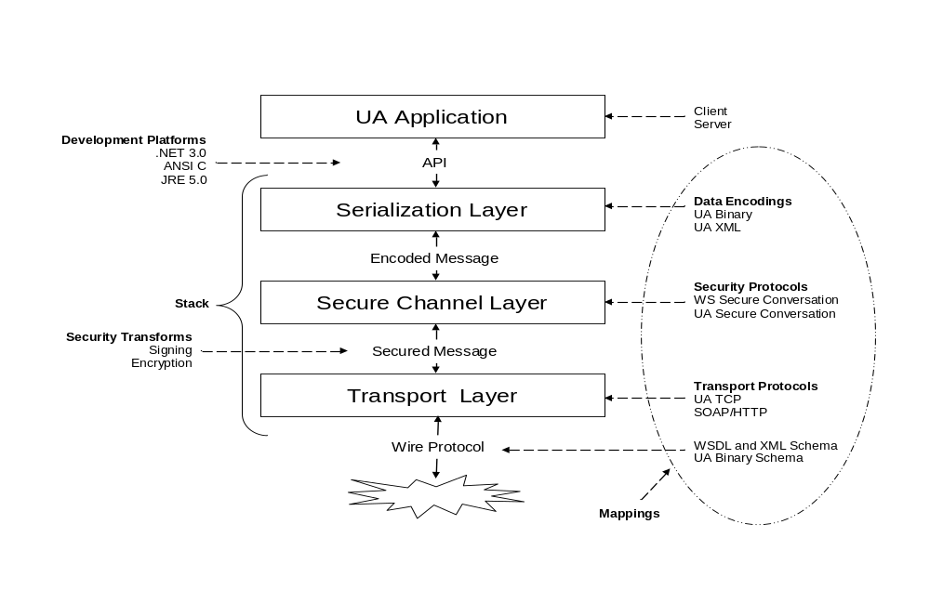
Figure 1 – The OPC UA Stack Overview

Data Encoding

General

Overview
This specification defines two data encodings: OPC UA Binary and OPC UA XML. It describes how to construct messages using each of these encodings.

Built-in Types
All OPC UA DataEncodings are based on rules that are defined for a standard set of built-in types. These built-in types are then used to construct structures, arrays and messages. The built-in types are described in Table 1.
Table 1 – Built-in Data Types
ID | Name | Description
1 | Boolean | A two-state logical value (true or false).
2 | SByte | An integer value between -128 and 127.
3 | Byte | An integer value between 0 and 256.
4 | Int16 | An integer value between -32768 and 32767.
5 | UInt16 | An integer value between 0 and 65535.
6 | Int32 | An integer value between – 2147483648 and 2147483647.
7 | UInt32 | An integer value between 0 and 4294967295.
8 | Int64 | An integer value between – 9223372036854775808 and 9223372036854775807
9 | UInt64 | An integer value between 0 and 18446744073709551615.
10 | Float | An IEEE single precision (32 bit) floating point value.
11 | Double | An IEEE double precision (64 bit) floating point value.
12 | String | A sequence of Unicode characters.
13 | DateTime | An instance in time.
14 | Guid | A 16 byte value that can be used as a globally unique identifier.
15 | ByteString | A sequence of octets.
16 | XmlElement | An XML element.
17 | NodeId | An identifier for a node in the address space of an OPC UA server.
18 | ExpandedNodeId | A NodeId that allows the namespace URI to be specified instead of an index.
19 | StatusCode | A numeric identifier for a error or condition that is associated with a value or an operation.
20 | QualifiedName | A name qualified by a namespace.
21 | LocalizedText | Human readable text with an optional locale identifier.
22 | ExtensionObject | A structure that contains an application specific data type that may not be recognized by the receiver.
23 | DataValue | A data value with an associated status code and timestamps.
24 | Variant | A union of all of the types specified above.
25 | DiagnosticInfo | A structure that contains detailed error and diagnostic information associated with a StatusCode.

Most of these data types are the same as the abstract types defined in Part 3 and Part 4, however, the ExtensionObject and Variant types are defined in this document. In addition, this document defines a representation for the Guid type defined in Part 3.

Guid
A Guid is a 16-byte globally unique identifier with the layout shown in Table 2.
Table 2 – Guid Structure
Component | Data Type
Data1 | UInt32
Data2 | UInt16
Data3 | UInt16
Data4 | Byte[8]

Guid values may be represented as a string in this form:
<Data1>-<Data2>-<Data3>-<Data4[0:1]>-<Data4[2:7]>
Where Data1 is 8 characters wide, Data2 and Data3 are 4 characters wide and each Byte in Data4 is 2 characters wide. Each value is formatted as a hexadecimal number padded zeros. A typical Guid value would look like this when formatted as a string:
C496578A-0DFE-4b8f-870A-745238C6AEAE

ExtensionObject
An ExtensionObject is a container for any complex data types which cannot be encoded as one of the other built-in data types. The ExtensionObject contains a complex value serialized as a sequence of bytes or as an XML element. It also contains an identifier which indicates what data it contains and how it is encoded.
Complex data types are represented in a Server address space as sub-types of the Structure data type. The encodings available for any given complex data type are represented as a DataTypeEncoding Object in the Server address space. The NodeId for the DataTypeEncoding Object is the identifier stored in the ExtensionObject. Clause 5.8 of Part 3 describes how DataTypeEncoding node are related to other nodes the address space.
Server implementers should use namespace qualified numeric NodeIds for any DataTypeEncoding Objects they define. This will minimize the overhead introduced by packing complex data values into ExtensionObjects.

Variant
A Variant is a union of all built-in data types including an ExtensionObject. Variants can also contain arrays of any of these built-in types. Variants are used to store any value or parameter with a data type of BaseDataType or one of its subtypes.
Variants can be empty. An empty Variant is described as having a Null value and should be treated like a NULL column in a SQL database. A Null value in a Variant may not be the same as a Null value for data types that support Nulls such as Strings. For this reason, all DataEncodings shall preserve this distinction when encoding Variants.
Variants can contain arrays of Variants but they cannot directly contain another Variant.
Variants cannot contain arrays of Bytes. Parameters that are defined as arrays of Bytes are stored as ByteStrings in a Variant.
DiagnosticInfo type only has meaning when returned in a response message with an associated StatusCode. As a result, Variants cannot contain instances of DiagnosticInfo.
Variables with a DataType of BaseDataType are mapped to a Variant, however, the ValueRank and ArrayDimensions Attributes place restrictions on what is allowed in the Variant. For example, if the ValueRank is Scalar then the Variant may only contain scalar values.

OPC UA Binary

General
The OPC UA Binary Encoding is a data format developed to meet the performance needs of OPC UA applications. This format is designed primarily for fast encoding and decoding, however, the size of the encoded data on the wire was also a consideration.
The OPC UA Binary Encoding relies on several primitive data types with clearly defined encoding rules that can be sequentially written to or read from a binary stream. A structure is encoded by sequentially writing the encoded form of each field. If a given field is also a structure then the values of its fields are written sequentially before writing the next field in the containing structure. All fields shall be written to the stream even if they contain Null values. The encodings for each primitive type specify how to encode a Null value for the type.
The OPC UA Binary Encoding does not include any type or field name information because all OPC UA applications are expected to have advance knowledge of the services and structures that they support. An exception is an ExtensionObject which provides an identifier and a size for the complex structure it represents. This allows a decoder to skip over types that it does not recognize.

Built-in Types

Boolean
A Boolean value shall be encoded as a single byte where a value of 0 (zero) is false and any non-zero value is true.
Encoders shall use the value of 1 to indicate a true value; however, decoders shall treat any non-zero value as true.

Integer
All integer types shall be encoded as little endian values where the least significant byte appears first in the stream.
The Figure 2 illustrates how the value 1,000,000,000 (Hex: 3B9ACA00) should be encoded as a 32 bit integer in the stream.

Figure 2 – Encoding Integers in a Binary Stream

Floating Point
All floating point values shall be encoded with the appropriate IEEE-754binary representation which has three basic components: the sign, the exponent, and the fraction. The bit ranges assigned to each component depend on the width of the type. Table 3 lists the bit ranges for the supported floating point types.
Table 3 – Supported Floating Point Types
Name | Width (bits) | Fraction | Exponent | Sign
Float | 32 | 0-22 | 23-30 | 31
Double | 64 | 0-51 | 52-62 | 63
In addition, the order of bytes in the stream is significant. All floating point values shall be encoded with the least significant byte appearing first (i.e. little endian).
The Figure 3 illustrates how the value -6.5 (Hex: C0D00000) should be encoded as a Float.

Figure 3 – Encoding Floating Points in a Binary Stream

String
All String values are encoded as a sequence of UTF8characters without a null terminator and preceded by the length in bytes..
The length in bytes is encoded as Int32. A value of -1 is used to indicate a ‘null’ string.
Figure 4 illustrates how the multilingual string “水Boy” should be encoded in a byte stream.

Figure 4 – Encoding Strings in a Binary Stream

DateTime
A DateTime value shall be encoded as a 64-bit signed integer (see Clause 5.2.2.2) which represents the number of 100 nanosecond intervals since January 1, 1601 (UTC)..
Not all platforms will be able to represent the full range of dates and times that can be represented with this encoding. For example, the UNIX time_t structure only has a 1 second resolution and cannot represent dates prior to 1970. For this reason, a number of rules shall be applied when dealing with date/time values that exceed the dynamic range of a platform. These rules are:
- A date/time value is encoded as 0 if either:
  - The value equal to or earlier than 1601-01-01 12:00AM
  - The value is the earliest date that can be represented with the platform’s encoding.
- A date/time is encoded as the maximum value for an Int64 if either:
  - The value is equal to or greater than 9999-01-01 11:59:59PM
  - The value is the latest date that can be represented with the platform’s encoding
- A date/time is decoded as the earliest time that can be represented on the platform if either:
  - The encoded value is 0
  - The encoded value represents a time earlier than the earliest time that can be represented with the platform’s encoding.
- A date/time is decoded as the latest time that can be represented on the platform if either:
  - The encoded value is the maximum value for an Int64
  - The encoded value represents a time later than the latest time that can be represented with the platform’s encoding.
These rules imply that the earliest and latest times that can be represented on a given platform are invalid date/time values and should be treated that way by applications.
A decoder shall truncate the value if a decoder encounters a DateTime value with a resolution that is greater than the resolution supported on the platform.

Guid
A Guid is encoded a the structure shown in Table 2. The fields are encode sequentially according to the data type for field.
Figure 5 illustrates how the Guid “72962B91-FA75-4ae6-8D28-B404DC7DAF63” should be encoded in a byte stream.
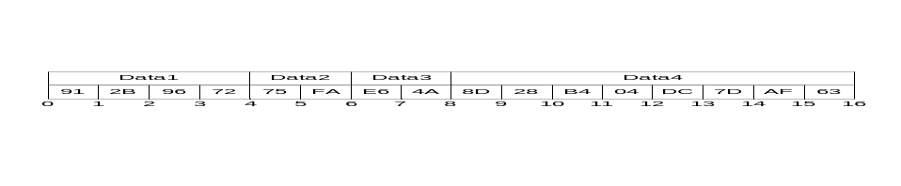
Figure 5 – Encoding Guids in a Binary Stream

ByteString
A ByteString is encoded as sequence of bytes preceded by its length in bytes. The length is encoded as a 32-bit signed integer as described above.
If the length of the byte string is -1 then the byte string is ‘null’.

XmlElement
An XmlElement is an XML fragment serialized as UTF-8 string and then encoded as ByteString
Figure 6 illustrates how the XmlElement “<A>Hot水</A>” should be encoded in a byte stream.
. 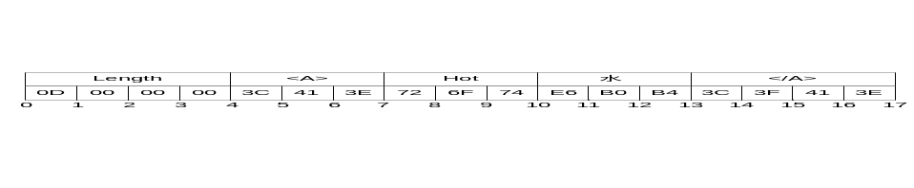
Figure 6 – Encoding XmlElements in a Binary Stream

NodeId
The components of a NodeId are described the Table 4.
Table 4 – NodeId Components
Name | Data Type | Description
Namespace | UInt16 | The index for a namespace URI.  An index of 0 is used for OPC UA defined NodeIds.
IdentifierType | Enum | The format and data type of the identifier  The value may be one of the following:  NUMERIC - the value is an UInteger;  STRING - the value is String;  GUID - the value is a Guid;  OPAQUE - the value is a ByteString;
Value | * | The identifier for a node in the address space of an OPC UA server.

The encoding of a NodeId varies according to the contents of the instance. For that reason the first byte of the encoded form indicates the format of the rest of the encoded NodeId. The possible encoding formats are shown in Table 5. The tables that follow describe the structure of the each possible format (they exclude the byte which indicates the format).
Table 5 – NodeId Encoding Values
Name | Value | Description
Two Byte | 0x00 | A numeric value that fits into the two byte representation.
Four Byte | 0x01 | A numeric value that fits into the four byte representation.
Numeric | 0x02 | A numeric value that does not fit into the two or four byte representations.
String | 0x03 | A String value.
Guid | 0x04 | A Guid value.
ByteString | 0x05 | An opaque (ByteString) value.
NamespaceUri Flag | 0x80 | See discussion of ExpandedNodeId in Clause 5.2.2.10.
ServerIndex Flag | 0x40 | See discussion of ExpandedNodeId in Clause 5.2.2.10.

The standard NodeId encoding has the structure shown in Table 6. The standard encoding is used for all formats that do not have an explicit format defined.
Table 6 – Standard NodeId Binary Encoding
Name | Data Type | Description
Namespace | UInt16 | The Namespace index.
Identifier | * | The identifier which is encoded according to the following rules:
  NUMERIC | UInt32
  STRING | String
  GUID | Guid
  OPAQUE | ByteString

An example of a String NodeId with Namespace = 1 and Identifier = “Hot水” is shown in Figure 7.
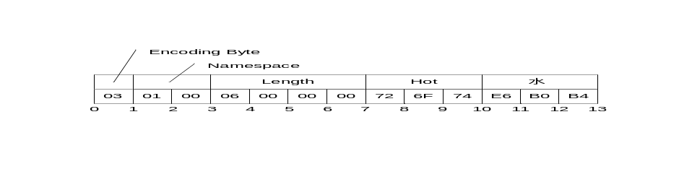
Figure 7 – A String NodeId
The Two Byte NodeId encoding has the structure shown in Table 7.
Table 7 – Two Byte NodeId Binary Encoding
Name | Data Type | Description
Identifier | Byte | The Namespace is the default OPC UA namespace (i.e. 0).  The Identifier Type is ‘Numeric’.  The Identifier shall be in the range 0 to 255.

An example of a Two Byte NodeId with Identifier = 72 is shown in Figure 8.

Figure 8 – A Two Byte NodeId
The Four Byte NodeId encoding has the structure shown in Table 8.
Table 8 – Four Byte NodeId Binary Encoding
Name | Data Type | Description
Namespace | Byte | The Namespace shall be in the range 0-255.
Identifier | UInt16 | The Identifier Type is ‘Numeric’.  The Identifier shall be an integer in the range 0-65535.

An example of a Four Byte NodeId with Namespace = 5 and Identifier = 1025 is shown in Figure 9.
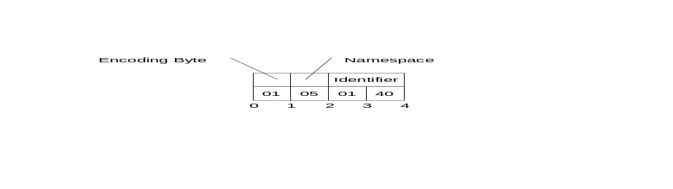
Figure 9 – A Four Byte NodeId

ExpandedNodeId
An ExpandedNodeId extends the NodeId structure by allowing the NamespaceUri to be explicitly specified instead of using the NamespaceIndex. The NamespaceUri is optional. If it is specified then the NamespaceIndex inside the NodeId shall be ignored.
The ExpandedNodeId is encoded by first encoding a NodeId as described in Clause 5.2.2.9 and then encoding NamespaceUri as a String.
An instance of an ExpandedNodeId may still use the NamespaceIndex instead of the NamespaceUri. In this case, the NamespaceUri is not encoded in the stream. The presence of the NamespaceUri in the stream is indicated by setting the NamespaceUri flag in the encoding format byte for the NodeId.
If the NamespaceUri is present then the encoder shall encode the NamespaceIndex as 0 in the stream when the NodeId portion is encoded. The unused NamespaceIndex is included in the stream for consistency,
An ExpandedNodeId may also have a ServerIndex which is encoded as a UInt32 after the NamespaceUri. The ServerIndex flag in the NodeId encoding byte indicates whether the ServerIndex is present in the stream. The ServerIndex is omitted if it is equal to zero.
The ExpandedNodeId encoding has the structure shown in Table 9.
Table 9 – ExpandedNodeId Binary Encoding
Name | Data Type | Description
NodeId | NodeId | The NamespaceUri and ServerIndex flags in the NodeId encoding indicate whether those fields are present in the stream.
NamespaceUri | String | Not present if Null or Empty.
ServerIndex | UInt32 | Not present if 0.

StatusCode
A StatusCode is encoded as a UInt32.

DiagnosticInfo
A DiagnosticInfo structure is described in Part 4 Clause 7.8. It specifies a number of fields that could be missing. For that reason, the encoding uses a bit mask to indicate which fields are actually present in the encoded form.
As described in Part 4, the SymbolicId, NamespaceUri, LocalizedText and Locale fields are indexes in a string table which is returned in the response header. Only the index of the string in this table is encoded. An index of -1 indicates that there is no value for the string.
Table 10 – DiagnosticInfo Binary Encoding
Name | Data Type | Description
Encoding Mask | Byte | A bit mask that indicates which fields are present in the stream.  The mask has the following bits:
  0x01 | Symbolic Id
  0x02 | Namespace
  0x04 | LocalizedText
  0x08 | Locale
  0x10 | Additional Info
  0x20 | InnerStatusCode
  0x40 | InnerDiagnosticInfo
SymbolicId | Int32 | A symbolic name for the status code.
NamespaceUri | Int32 | A namespace that qualifies the symbolic id.
LocalizedText | Int32 | A human readable summary of the status code.
Locale | Int32 | The locale used for the localized text.
Additional Info | String | Detailed application specific diagnostic information.
Inner StatusCode | StatusCode | A status code provided by an underlying system.
Inner DiagnosticInfo | DiagnosticInfo | Diagnostic info associated with the inner status code.

QualifiedName
A QualifiedName structure is encoded as shown in Table 11.
The abstract QualifiedName structure is defined in Part 3 Clause 8.4.

Table 11 – QualifiedName Binary Encoding
Name | Data Type | Description
NamespaceIndex | UInt16 | The namespace index.
Name | String | The name.

LocalizedText
A LocalizedText structure contains two fields that could be missing. For that reason, the encoding uses a bit mask to indicate which fields are actually present in the encoded form.
The abstract LocalizedText structure is defined in Part 3 Clause 8.6.
Table 12 – LocalizedText Binary Encoding
Name | Data Type | Description
EncodingMask | Byte | A bit mask that indicates which fields are present in the stream.  The mask has the following bits:
  0x01 | Locale
  0x02 | Text
Locale | String | The locale.  Omitted is null or empty.
Text | String | The text in the specified locale.  Omitted is null or empty.

ExtensionObject
An ExtensionObject is encoded as sequence of bytes prefixed by the NodeId of its DataTypeEncoding and the number of bytes encoded.
An ExtensionObject may be encoded by the application which means it is passed as a ByteString or an XmlElement to the encoder. In this case, the encoder will be able to write the number of bytes in the object before it encodes the bytes. However, an ExtensionObject may know how to encode/decode itself which means the encoder shall calculate the number of bytes before it encodes the object or it shall be able seek backwards in the stream and update the length after encoding the body.
When a decoder encounters an ExtensionObject it shall check if it recognizes the DataTypeEncoding identifier. If it does then it can call the appropriate function to decode the object body. If the decoder does not recognize the type it shall use the EncodingMask to determine if the body is a ByteString or an XmlElement and then decode the object body.
The serialized form of a ExtensionObject is shown in Table 13.
Table 13 – Extension Object Binary Encoding
Name | Data Type | Description
TypeId | NodeId | The identifier for the DataTypeEncoding node in the server's address space. ExtensionObjects defined by the OPC UA specification have a numeric node identifier assigned to them with a NamespaceIndex of 0. The numeric identifiers are defined in Annex A.1.
Encoding | Byte | An enumeration that indicates how the body is encoded.  The parameter may have the following values:
  0x00 | No body is encoded,
  0x01 | The body is encoded as a ByteString.
  0x02 | The body is encoded as a XmlElement.
Length | Int32 | The length of the object body.  If the length is not specified then the it set to -1.  The length may be omitted for any DataTypeEncoding defined in this document (See Annex A).  The length shall be specified for all user defined types.
Body | Byte[*] | The object body.  This field contains the raw bytes for ByteString bodies.  For XmlElement bodies this field contains the XML encoded as UTF-8 without any null terminator.

ExtensionObjects are used in two contexts: as values contained in Variant structures or as parameters in OPC UA messages.

Variant
An Variant is a union of the built-in types.
The structure of an Variant is shown in Table 14.
Table 14 – Variant Binary Encoding
Name | Data Type | Description
EncodingMask | Byte | The type of data encoded in the stream.  The mask has the following bits assigned:
  0:5 | Built-in Type Id (see Table 1)
  6 | True if the Array Dimensions field is encoded.
  7 | True if an array of values is encoded.
ArrayLength | Int32 | The number of elements in the array.  This field is only present if the array bit is set in the encoding mask.  Multi-dimensional arrays are encoded as a one dimensional array and this field specifies the total number of elements. The original array can be reconstructed from the dimensions that are encoded after the value field.  Higher rank dimensions are serialized first. e.g. an array with dimensions [2,2,2] is written in this order:  [0,0,0], [0,0,1], [0,1,0], [0,1,1], [1,0,0], [1,0,1], [1,1,0], [1,1,1]
Value | * | The value encoded according to its data type.  If the array bit is set in the encoding mask then each element in the array is encoded sequentially. Since many types have variable length encoding each element shall be decoded in order.  The value shall not be an Variant but it could be an array of Variants.  Arrays of Bytes are not permitted.
ArrayDimensions | Int32[] | The length of each dimension.  This field is only present if the array dimensions flag is set in the encoding mask. The lower rank dimensions appear first in the array.

The possible types and their identifiers that can be encoded in an Variant are shown in Table 1.

DataValue
A DataValue is always preceded by a mask that indicates which fields are present in the stream.
The fields of a DataValue are described in Table 15.
Table 15 – Data Value Binary Encoding
Name | Data Type | Description
Encoding Mask | Byte | A bit mask that indicates which fields are present in the stream.  The mask has the following bits:
  0x01 | False if the Value is Null
  0x02 | False if the StatusCode is Good
  0x04 | False if the Source Timestamp is DateTime.MinValue.
  0x08 | False if the Server Timestamp is DateTime.MinValue.
  0x10 | False if the Source Picoseconds is 0.
  0x20 | False if the Server Picoseconds is 0.
Value | Variant | The value.  Not present if the Value bit in the EncodingMask is False.
Status | StatusCode | The status associated with the value.  Not present if the StatusCode bit in the EncodingMask is False.
SourceTimestamp | DateTime | The source timestamp associated with the value.  Not present if the SourceTimestamp bit in the EncodingMask is False.
SourcePicoseconds | UInt16 | The number of 10 picoseconds intervals for the SourceTimestamp.  Not present if the SourcePicoseconds bit in the EncodingMask is False.
ServerTimestamp | DateTime | The server timestamp associated with the value.  Not present if the ServerTimestamp bit in the EncodingMask is False.
ServerPicoseconds | UInt16 | The number of 10 picoseconds intervals for the ServerTimestamp.  Not present if the ServerPicoseconds bit in the EncodingMask is False.

The Picoseconds fields store the difference between a high resolution timestamp with a resolution of 10ps and the Timestamp field value which only has a 100ns resolution. The Picoseconds fields shall contain values less than 10000. The decoder shall treat values greater than or equal to 10000 as the value ‘9999’.

Enumerations
Enumerations are encoded as Int32 values.

Arrays
Arrays that occur outside of a Variant are encoded as a sequence of elements preceded by the number of elements encoded as an Int32 value. If an array is Null then its length is encoded as -1. An array of zero length is different from an array that is Null so encoders and decoders shall preserve this distinction.
Multi-dimensional arrays can only be encoded within a Variant.

Structures
Structures are encoded as a sequence of fields in the order that they appear in the definition. The encoding for each field is determined by the data type for the field.
All fields specified in the complex type shall be encoded.
Structures do not have a Null value. If an encoder is written in a programming language that allows structures to have null values then the encoder shall create a new instance with default values for all fields and serialize that. Encoders shall not generate an encoding error in this situation.
The following is an example of a structure using C++ syntax:

class Type2
{
int A;
int B;
};

class Type1
{
int X;
int NoOfY;
Type2* Y;
int Z;
};

The Y field is a pointer to an array with a length stored in NoOfY.
An instance of Type1 which contains an array of two Type2 instances would be encoded as 37 byte sequence. If the instance of Type1 was encoded in an ExtensionObject it would have the encoded form shown in Table 16. The TypeId, Encoding and the Length are fields defined by the ExtensionObject. The encoding of the Type2 instances do not include any type identifier because it is explicitly defined in Type1.
Table 16 – Sample OPC UA Binary Encoded Structure
Field | Bytes | Value
Type Id | 4 | The identifier for Type1
Encoding | 1 | 0x1 for ByteString
Length | 4 | 28
X | 4 | The value of field ‘X’
NoOfY | 4 | 2
Y.A | 4 | The value of field ‘Y[0].A’
Y.B | 4 | The value of field ‘Y[0].B’
Y.A | 4 | The value of field ‘Y[1].A’
Y.B | 4 | The value of field ‘Y[1].B’
Z | 4 | The value of field ‘Z’

Messages
Messages are encoded as ExtensionObjects. The parameters in each message are serialized in the same way the fields of a structure are serialized. The Type Id field contains the DataTypeEncoding identifier for the message. The Length field is omitted since the messages are defined by the OPC UA specification.
Each UA service described in Part 4 has a request and response message. The DataTypeEncoding ids assigned to each service are in Annex A.1.

XML

Built-in Types

General
Most built-in types are encoded in XML using the formats defined in XML Schema Part 2 specification. Any special restrictions or usages are discussed below. Some of the built-in types have an XML Schema defined for them using the syntax defined in XML Schema Part 1.
The prefix xs: is used to denote a symbol defined by the XML Schema specification.

Boolean
A Boolean value is encoded as an xs:boolean value.

Integer
Integer values are encoded using one of the sub types of the xs:decimal type. The mappings between the OPC UA integer types and XML schema data types are shown in Table 17.
Table 17 – XML Data Type Mappings for Integers
Name | XML Type
SByte | xs:byte
Byte | xs:unsignedByte
Int16 | xs:short
UInt16 | xs:unsignedShort
Int32 | xs:int
UInt32 | xs:unsignedInt
Int64 | xs:long
UInt64 | xs:unsignedLong

Floating Point
Floating point values are encoded using one of the XML floating point types. The mappings between the OPC UA floating point types and XML schema data types are shown in Table 18.
Table 18 – XML Data Type Mappings for Floating Points
Name | XML Type
Float | xs:float
Double | xs:double

String
A String value is encoded as an xs:string value.

DateTime
A DateTime value is encoded as an xs:dateTime value.
All DateTime values shall be encoded as UTC times or with the time zone explicitly specified.
Correct:
2002-10-10T00:00:00+05:00
2002-10-09T19:00:00Z
Incorrect:
2002-10-09T19:00:00
It is recommended that all xs:dateTime values be represented in UTC format.
The earliest and latest date/time values that can be represented on a platform have special meaning and shall not be literally encoded in XML.
The earliest date/time value on a platform shall be encoded in XML as '0001-01-01T00:00:00Z'.
The latest date/time value on a platform shall be encoded in XML as '9999-12-31T11:59:59Z'
If a decoder encounters a xs:dateTime value that cannot be represented on the platform it should convert the value to either the earliest or latest date/time that can be represented on the platform. The XML decoder should not generate an error if it encounters an out of range date value.
The earliest date/time value on a platform is equivalent to a Null date/time value.

Guid
A Guid is encoded using the string representation defined in Section 5.1.3.
The XML schema for a Guid is:
<xs:complexType name="Guid">
<xs:sequence>
<xs:element name="String" type="xs:string" minOccurs="0" />
</xs:sequence>
</xs:complexType>

ByteString
A ByteString value is encoded as an xs:base64Binary value.
The XML schema for a ByteString is:
<xs:element name="ByteString" type="xs:base64Binary" nillable="true" />

XmlElement
An XmlElement value is encoded as a xs:complexType with the following XML schema:
<xs:complexType name="XmlElement">
<xs:sequence>
<xs:any minOccurs="0" maxOccurs="1" processContents="lax" />
</xs:sequence>
</xs:complexType>

XmlElements may only be used inside Variant or ExtensionObject values.

NodeId
A NodeId value is encoded as a xs:string with the syntax:
ns=<namespaceindex>;<type>=<value>
The elements of the syntax are described in Table 19.
Table 19 – Components of NodeId
Field | Data Type | Description
<namespaceindex> | UInt16 | The namespace index formatted as a base 10 number.  If the index is 0 then the entire 'ns=0;' clause shall be omitted.
<type> | Enum | A flag that specifies the identifier type.  The flag has the following values:
  i | NUMERIC (UInteger)
  s | STRING (String)
  g | GUID (Guid)
  b | OPAQUE (ByteString)
<value> | * | The identifier encoded as string.  The identifier is formatted using the XML data type mapping for the identifier type.  Note that the identifier may contain any non-null UTF8 character including whitespace.

Examples of NodeIds:

i=13
ns=10;i=-1
ns=10;s=Hello:World
g=09087e75-8e5e-499b-954f-f2a9603db28a
n=1;b=M/RbKBsRVkePCePcx24oRA==
The XML schema for a NodeId is:
<xs:complexType name="NodeId">
<xs:sequence>
<xs:element name="Identifier" type="xs:string" minOccurs="0" />
</xs:sequence>
</xs:complexType>

ExpandedNodeId
An ExpandedNodeId value is encoded as a xs:string with the syntax:
svr=<serverindex>;ns=<namespaceindex>;<type>=<value>
or
svr=<serverindex>;nsu=<uri>;<type>=<value>
Table 20 – Components of ExpandedNodeId
Field | Data Type | Description
<serverindex> | UInt32 | The server index formatted as a base 10 number.  If the server index is 0 then the entire 'svr=0;' clause shall be omitted.
<namespaceindex> | UInt16 | The namespace index formatted as a base 10 number.  If the namespace index is 0 then the entire 'ns=0;' clause shall be omitted.  The namespace index shall not be present if the URI is present.
<uri> | String | The namespace URI formatted as a string.  Any reserved characters in the URI shall be replaced with a ‘%’ followed by its 8 bit ANSI value encoded as two hexadecimal digits (case insensitive). For example, the character ‘;’ would be replaced by ‘%3B’.  The reserved characters are ‘;’ and ‘%’.  If the namespace URI is null or empty then 'nsu=;' clause shall be omitted.
<type> | Enum | A flag that specifies the identifier type.  This field is described in Table 19.
<value> | * | The identifier encoded as string.  This field is described in Table 19.

The XML schema for a ExpandedNodeId is:
<xs:complexType name="ExpandedNodeId">
<xs:sequence>
<xs:element name="Identifier" type="xs:string" minOccurs="0" />
</xs:sequence>
</xs:complexType>

StatusCode
A StatusCode is formatted in an xs:string as an 8 digit hexadecimal number.
The XML schema for a StatusCode is:
<xs:complexType name="StatusCode">
<xs:sequence>
<xs:element name="Code" type="xs:string" minOccurs="0" />
</xs:sequence>
</xs:complexType>

DiagnosticInfo
An DiagnosticInfo value is encoded as a xs:complexType with the following XML schema:
<xs:complexType name="DiagnosticInfo">
<xs:sequence>
<xs:element name="SymbolicId" type="xs:int" minOccurs="0" />
<xs:element name="NamespaceURI" type="xs:int" minOccurs="0" />
<xs:element name="LocalizedText" type="xs:int" minOccurs="0/>
<xs:element name="Locale" type="xs:int" minOccurs="0/>
<xs:element name="AdditionalInfo" type="xs:string" minOccurs="0" />
<xs:element name="InnerStatusCode" type="tns:StatusCode" minOccurs="0" />
<xs:element name="InnerDiagnosticInfo" type="tns:DiagnosticInfo"
minOccurs="0" />
</xs:sequence>
</xs:complexType>

QualifiedName
A QualifiedName value is encoded as a xs:complexType with the following XML schema:
<xs:complexType name="QualifiedName">
<xs:sequence>
<xs:element name="NamespaceIndex" type="xs:int" minOccurs="0" />
<xs:element name="Name" type="xs:string" minOccurs="0" />
</xs:sequence>
</xs:complexType>

LocalizedText
A LocalizedText value is encoded as a xs:complexType with the following XML schema:
<xs:complexType name="LocalizedText">
<xs:sequence>
<xs:element name="Locale" type="xs:string" minOccurs="0" />
<xs:element name="Text" type="xs:string" minOccurs="0" />
</xs:sequence>
</xs:complexType>

ExtensionObject
An ExtensionObject value is encoded as a xs:complexType with the following XML schema:
<xs:complexType name="ExtensionObject">
<xs:sequence>
<xs:element name="TypeId" type="tns:NodeId" minOccurs="0" />
<xs:element name="Body" minOccurs="0">
<xs:complexType>
<xs:sequence>
<xs:any minOccurs="0" processContents="lax"/>
</xs:sequence>
</xs:complexType>
</xs:element>
</xs:sequence>
</xs:complexType>
The body of the ExtensionObject contains a single element which is either a ByteString or XML encoded Structure. A decoder can distinguish between the two by inspecting the top level element. An element with the name tns:ByteString contains a OPC UA Binary encoded body. Any other name shall contain an OPC UA XML encoded body.
The TypeId is the NodeId for the DataTypeEncoding Object.

Variant
A Variant value is encoded as a xs:complexType with the following XML schema:
<xs:complexType name="Variant">
<xs:sequence>
<xs:element name="Value" minOccurs="0" nillable="true">
<xs:complexType>
<xs:sequence>
<xs:any minOccurs="0" processContents="lax"/>
</xs:sequence>
</xs:complexType>
</xs:element>
</xs:sequence>
</xs:complexType>

If the Variant represents a scalar value then it shall contain a single child element with the name of the built-in type. For example, the single precision floating point value 3.1415 would be encoded as:

<tns:Float>3.1415</tns:Float>

If the Variant represents a single dimensional array then it shall contain a single child element with the prefix 'ListOf' and the name built-in type. For example an array of strings would be encoded as:

<tns:ListOfString>
<tns:String>Hello</tns:String>
<tns:String>World</tns:String>
</tns:ListOfString>

If the Variant represents a Multidimensional array then it shall contain a child element with the name ‘Matrix’ with the two sub-elements shown in this example:

<tns:Matrix>
<tns:Dimensions>
<tns:Int32>2</tns:Int32>
<tns:Int32>2</tns:Int32>
</tns:Dimensions>
<tns:Elements>
<tns:String>A</tns:String>
<tns:String>B</tns:String>
<tns:String>C</tns:String>
<tns:String>D</tns:String>
</tns:Elements>
</tns:Matrix>

In this example, the array has the following elements:
[0,0] = "A"; [0,1] = "B"; [1,0] = "C"; [1,1] = "D"
The elements of a multi-dimensional array are always flattened into a single dimensional array where the higher rank dimensions are serialized first. This single dimensional array is encoded as a child of the ‘Elements’ element. The ‘Dimensions’ element is an array of Int32 values that specify the dimensions of the array starting with the lowest rank dimension. The multi-dimensional array can be reconstructed by using the dimensions encoded.
The complete set of built-in type names is found in Table 1.

DataValue
A DataValue value is encoded as a xs:complexType with the following XML schema:
<xs:complexType name="DataValue">
<xs:sequence>
<xs:element name="Value" type="tns:Variant" minOccurs="0" nillable="true" />
<xs:element name="StatusCode" type="tns:StatusCode" minOccurs="0" />
<xs:element name="SourceTimestamp" type="xs:dateTime" minOccurs="0" />
<xs:element name="SourcePicoseconds" type="xs:unsignedShort" minOccurs="0"/>
<xs:element name="ServerTimestamp" type="xs:dateTime" minOccurs="0" />
<xs:element name="ServerPicoseconds" type="xs:unsignedShort" minOccurs="0"/>
</xs:sequence>
</xs:complexType>

Enumerations
Enumerations that are used as parameters in the Messages defined in Part 4 are encoded as xs:string with the following syntax:
<symbol>_<value>
The elements of the syntax are described in Table 21.
Table 21 – Components of Enumeration
Field | Type | Description
<symbol> | String | The symbolic name for the enumerated value.
<value> | UInt32 | The numeric value associated with enumerated value.

For example, the XML schema for the NodeClass enumeration is:
<xs:simpleType name="NodeClass">
<xs:restriction base="xs:string">
<xs:enumeration value="Unspecified_0" />
<xs:enumeration value="Object_1" />
<xs:enumeration value="Variable_2" />
<xs:enumeration value="Method_4" />
<xs:enumeration value="ObjectType_8" />
<xs:enumeration value="VariableType_16" />
<xs:enumeration value="ReferenceType_32" />
<xs:enumeration value="DataType_64" />
<xs:enumeration value="View_128" />
</xs:restriction>
</xs:simpleType>

Enumerations that are stored in a Variant are encoded as an Int32 value.
For example, any Variable could have a value with a DataType of NodeClass. In this case the corresponding numeric value is placed in the Variant (e.g. NodeClass::Object would be stored as a 1).

Arrays
Arrays parameters are always encoded by wrapping the elements in a container element and inserting the container into the structure. The name of the container element should be the name of the parameter. The name of the element in the array shall be the type name.
For example, the Read service takes an array of ReadValueIds. The XML schema would look like:
<xs:complexType name="ListOfReadValueId">
<xs:sequence>
<xs:element name="ReadValueId" type="tns:ReadValueId"
minOccurs="0" maxOccurs="unbounded" nillable="true" />
</xs:sequence>
</xs:complexType>
The nillable attribute shall be specified because XML encoders will drop elements in arrays if those elements are empty.

Structures
Structures are encoded as a xs:complexType with all of the fields appearing in a sequence. All fields are encoded as an xs:element and have xs:maxOccurs set to 1.
For example, the Read service has a ReadValueId structure in the request. The XML schema would look like:
<xs:complexType name="ReadValueId">
<xs:sequence>
<xs:element name="NodeId" type="tns:NodeId" minOccurs="1" />
<xs:element name="AttributeId" type="xs:int" minOccurs="1" />
<xs:element name="IndexRange" type="xs:string"
minOccurs="0" nillable="true" />
<xs:element name="DataEncoding" type="tns:NodeId" minOccurs="1" />
</xs:sequence>
</xs:complexType>

Messages
Messages are encoded as an xs:complexType. The parameters in each message are serialized in the same way the fields of a structure are serialized.

Security Protocols

Security Handshake
All SecurityProtocols shall implement the OpenSecureChannel and CloseSecureChannel services defined in Part 4. These services specify how to establish a SecureChannel and how to apply security to messages exchanged over that SecureChannel. The messages exchanged and the security algorithms applied to them are shown in Figure 10.
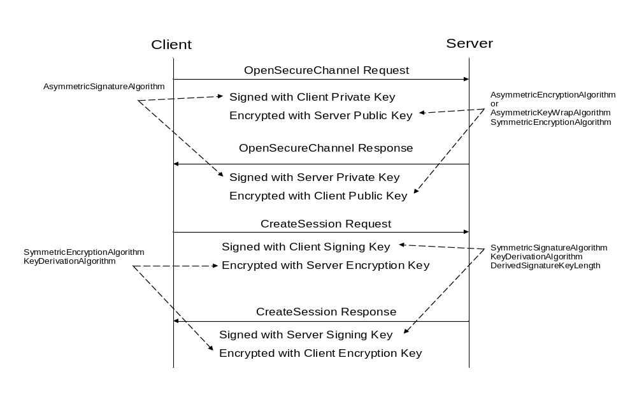
Figure 10 – The Security Handshake
Each SecurityProtocol mapping specifies exactly how to apply the security algorithms to the message. A set of security algorithms that shall be used together during a security handshake is called a SecurityPolicy. Part 7 defines standard SecurityPolicies as parts of the standard Profiles which OPC UA applications are expected to support. Part 7 also defines a URI for each standard SecurityPolicy.
A Stack is expected to have built in knowledge of the SecurityPolicies that it supports. Applications specify the SecurityPolicy they wish to use by passing the URI to the Stack.
Table 22 defines the contents of a SecurityPolicy. Each SecurityProtocol mapping specifies how to use each of the parameters in the SecurityPolicy. A SecurityProtocol mapping may not make use of all of the parameters.
Table 22 – SecurityPolicy
Name | Description
PolicyUri | The URI assigned to the SecurityPolicy.
SymmetricSignatureAlgorithm | The URI of the symmetric signature algorithm to use.
SymmetricEncryptionAlgorithm | The URI of the symmetric key encryption algorithm to use.
AsymmetricSignatureAlgorithm | The URI of the asymmetric signature algorithm to use.
AsymmetricKeyWrapAlgorithm | The URI of the asymmetric key wrap algorithm to use.
AsymmetricEncryptionAlgorithm | The URI of the asymmetric key encryption algorithm to use.
KeyDerivationAlgorithm | The key derivation algorithm to use.
DerivedSignatureKeyLength | The length in bits of the derived key used for message authentication.

The AsymmetricEncryptionAlgorithm is used when encrypting the entire message with an asymmetric key. Some SecurityProtocols do not encrypt the entire message with an asymmetric key. Instead, they use the AsymmetricKeyWrapAlgorithm to encrypt a symmetric key and then use the SymmetricEncryptionAlgorithm to encrypt the message.
The AsymmetricSignatureAlgorithm is used to sign a message with an asymmetric key.
The KeyDerivationAlgorithm is used to create the keys used to secure messages sent over the SecureChannel. The length of the keys used for encryption are implied by the SymmetricEncryptionAlgorithm. The length of the keys used for creating symmetric signatures depend on the SymmetricSignatureAlgorithm and may be different from the encryption key length.

Certificates

General
OPC UA Applications use Certificates to store the public keys needed for asymmetric cryptography operations. All SecurityProtocols use X509 Version 3 Certificates (see X509) encoded using the DER format (see X690). Certificates used by OPC UA Applications shall also conform to RFC 3280 which defines a profile for X509 Certificates when they are used as part of an Internet based application.
The ServerCertificate and ClientCertificate parameters used in the abstract OpenSecureChannel service are instances of the ApplicationInstanceCertificate data type. Clause 6.2.2 describes how to create an X509 certificate that can be used as an ApplicationInstanceCertificate.
The ServerSoftwareCertificates and ClientSoftwareCertificates parameters in the abstract CreateSession and ActivateSession services are instances of the SignedSoftwareCertificate data type. Clause 6.2.3 describes how to create an X509 Certificate that can be used as an SignedSoftwareCertificate.

Application Instance Certificate
An ApplicationInstanceCertificate is a ByteString containing the DER encoded form of an X509v3 Certificate. This Certificate is issued by certifying authority and identifies an instance of an application running on a single host. The X509v3 fields contained in an ApplicationInstance Certificate are described in Table 23. The fields are defined completely in RFC 3280.
Table 23 – ApplicationInstanceCertificate
Name | Abstract Parameter | Description
ApplicationInstanceCertificate |  | An X509v3 Certificate.
version | version | shall be “V3”
serialNumber | serialNumber | The serial number assigned by the issuer.
signatureAlgorithm | signatureAlgorithm | The algorithm used to sign the Certificate.
signature | signature | The signature created by the Issuer.
issuer | issuer | The distinguished name of the Certificate used to create the signature.  The issuer field is completely described in RFC 3280.
validity | validTo, validFrom | When the Certificate becomes valid and when it expires.
subject | subject | The distinguished name of the application instance.  The Common Name attribute shall be specified and should be the productName or a suitable equivalent. The Organization Name attribute shall be the name of the Organization that executes the application instance. This organization is usually not the vendor of the application.  Other attributes may be specified.  The subject field is completely described in RFC 3280.
subjectAltName | applicationUri,  hostnames | The alternate names for the application instance.  Shall include a uniformResourceIdentifier which is equal to the applicationUri.  Servers shall specify a dNSName or IPAddress which identifies the machine where the application instance runs. Additional dNSNames may be specified if the machine has multiple names. The IPAddress should not be specified if the Server has dNSName.  The subjectAltName field is completely described in RFC 3280.
publicKey | publicKey | The public key associated with the Certificate.
keyUsage | keyUsage | Specifies how the certificate key may be used.  Shall include digitalSignature, nonRepudiation, keyEncipherment and dataEncipherment.  Other key uses are allowed.
extendedKeyUsage | keyUsage | Specifies additional key uses for the Certificate.  Shall specify 'serverAuth and/or clientAuth.  Other key uses are allowed.

Signed Software Certificate
A SignedSoftwareCertificate is a ByteString containing the DER encoded form of an X509v3 Certificate. This Certificate is issued by a certifying authority and contains an X509v3 extension with the SoftwareCertificate which specifies the claims verified by the certifying authority. The X509v3 fields contained in a SignedSoftwareCertificate are described in Table 24. The fields are defined completely in RFC 3280.
Table 24 – SignedSoftwareCertificate
Name |  | Description
SignedSoftwareCertificate |  | An X509v3 Certificate.
version | version | Shall be “V3”
serialNumber | serialNumber | The serial number assigned by the issuer.
signatureAlgorithm | signatureAlgorithm | The algorithm used to sign the Certificate.
signature | signature | The signature created by the Issuer.
issuer | issuer | The distinguished name of the Certificate used to create the signature.  The issuer field is completely described in RFC 3280.
validity | validTo, validFrom | When the Certificate becomes valid and when it expires.
subject | subject | The distinguished name of the product.  The Common Name attribute shall be the same as the productName in the SoftwareCertificate and the Organization Name attribute shall the vendorName in the SoftwareCertificate.  Other attributes may be specified.  The subject field is completely described in RFC 3280.
subjectAltName | productUri | The alternate names for the product.  shall include a ‘uniformResourceIdentifier’ which is equal to the productUri specified in the SoftwareCertificate.  The subjectAltName field is completely described in RFC 3280.
publicKey | publicKey | The public key associated with the Certificate.
keyUsage | keyUsage | Specifies how the certificate key may be used.  shall be ‘digitalSignature’ and ‘nonRepudiation’  Other key uses are not allowed.
extendedKeyUsage | keyUsage | Specifies additional key uses for the Certificate.  May specify ‘codeSigning’.  Other key usages are not allowed.
softwareCertificate | softwareCertificate | The XML encoded form of the SoftwareCertificate stored as UTF8 text.  Clause 5.3.4 describes how to encode a SoftwareCertificate in XML.  The ASN.1 Object Identifier (OID) for this extension is: 1.2.840.113556.1.8000.2264.1.6.1

WS Secure Conversation

Overview
Any message sent via SOAP may be secured with the WS Secure Conversation protocol. This protocol specifies a way to negotiate shared secrets via WS Trust and then use these secrets to secure messages exchanged with the mechanisms defined in WS Security.
The mechanisms for actually signing XML elements are described in the XML Signature specification. The mechanisms for encrypting XML elements are described the XML Encryption specification.
WS Security Policydefines standard algorithm suites which can be used to secure SOAP messages. These algorithm suites map directly onto the SecurityPolicies that are defined in Part 7. WS-I Basic Security Profile 1.1 defines best practices when using WS-Security which will help ensure interoperability. All OPC UA implementations shall conform to this specification. illustrates the relationship between the different WS-* specifications that are used by this mapping. The versions of the WS-* specifications shown in the diagram were the most current versions at the time of publication. Part 7 may define Profiles that require support for future versions of these specifications.
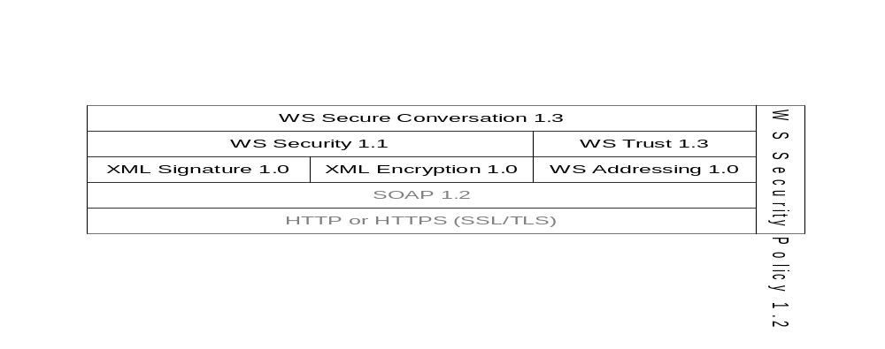
Figure 11 – The XML Web Services Stack
Figure 12 illustrates how these WS-* specifications are used in the security handshake.
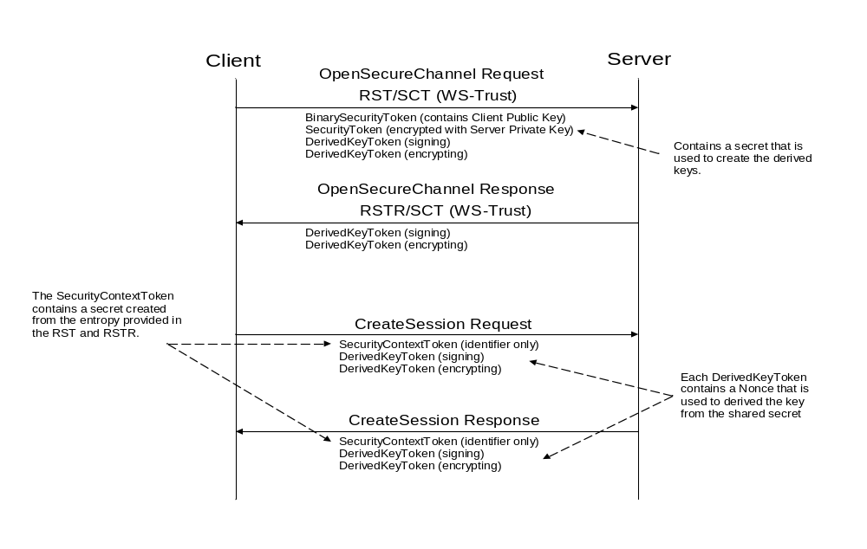
Figure 12 – The WS Secure Conversation Handshake
The RST (Request Security Token) and RSTR (Request Security Token Response) messages are defined by WS Trust. WS Secure Conversation defines new actions for these messages that tell the server that the client wants to create a SCT (Security Context Token). The SCT contains the shared keys that the applications use to secure messages sent over the SecureChannel.
Individual messages are secured with keys derived from the SCT using the mechanism defined in WS Secure Conversation. The sections below specify the structure of the individual messages and illustrate which features from the WS-* specifications are required to implement the OPC UA security handshake.

Notation
SOAP messages use XML elements defined in a number of different specifications. This document uses the prefixes in Table 25 to identify the specification that defines an XML element.
Table 25 – WS-* Namespace Prefixes
Prefix | Specification
wsu | WS-Security Utilities
wsse | WS-Security Extensions
wst | WS-Trust
wsc | WS-Secure Conversation
wsa | WS-Addressing
xenc | XML Encryption

Request Security Token (RST/SCT)
The Request Security Token message implements the abstract OpenSecureChannel request message defined in Part 4. The syntax of this message is defined by WS Trust. The structure of the message is described in detail in WS Secure Conversation.
This message shall have the following tokens:
- A wsse:BinarySecurityToken containing the Client’s Public Key. The public key is sent in a DER encoded X509v3 certificate.
- An encrypted wsse:SecurityToken containing ClientNonce used to derive keys. This token shall be encrypted with the AsymmetricKeyWrapAlgorithm and the public key associated with the Server’s Application Instance Certificate.
- A wsc:DerivedKeyToken which is used to sign the body, the WS Addressing headers and the wsu:Timestamp header using the SymmetricSignatureAlgorithm. The signature element shall then be signed using the AsymmetricSignatureAlgorithm with the Client’s Private Key. The wsc:DerivedKeyToken shall also specify a Nonce.
- A wsc:DerivedKeyToken which is used to encrypt the body of the message using the SymmetricEncryptionAlgorithm.
This message shall have the wsa:Action, wsa:MessageId, wsa:ReplyTo and wsa:To headers defined by WS Addressing. The message shall also have a wsu:Timestamp header defined by WS Security. These headers shall also be signed with the derived key used to sign the message body.
The signature shall be calculated before applying encryption and the signature shall be encrypted.
The mapping between the OpenSecureChannel request parameters and the elements of the RST/SCT message are shown in Table 26.
Table 26 – RST/SCT Mapping to an OpenSecureChannel Request
OpenSecureChannel Parameter | RST/SCT Element | Description
clientCertificate | wsse:BinarySecurityToken | Passed in the SOAP header.
requestType | wst:RequestType | Shall be “http://schemas.xmlsoap.org/ws/2005/02/trust/Issue” when creating a new SCT.  Shall be “http://schemas.xmlsoap.org/ws/2005/02/trust/Renew” when renewing a SCT.
secureChannelId | wsse:SecurityTokenReference | Passed in the SOAP header when renewing an SCT.
securityMode  securityPolicyUri | wst:SignatureAlgorithm  wst:EncryptionAlgorithm  wst:KeySize | These elements describe the SecurityPolicy requested by the client.  These elements shall match the SecurityPolicy used by the endpoint that the client wishes to connect to.  These elements are optional.
clientNonce | wst:Entropy | This contains the nonce specified by the client.  The nonce is specified with the wst:BinarySecret element.
requestedLifetime | wst:Lifetime | The requested lifetime for the SCT.  This element is optional.

Request Security Token Response (RSTR/SCT)
The Request Security Token Response message implements the abstract OpenSecureChannel response message defined in Part 4. The syntax of this message is defined by WS Trust. The use of the message is described in detail in WS Secure Conversation. This message not signed or encrypted with the asymmetric algorithms as described in the Part 4. The symmetric algorithms and a key provided in the request message are used instead.
This message shall have the following tokens:
- A wsc:DerivedKeyToken which is used to sign the body, the WS Addressing headers and the wsu:Timestamp header using the SymmetricSignatureAlgorithm. This key is derived from the encrypted SecurityToken specified in the RST/SCT message. The wsc:DerivedKeyToken shall also specify a Nonce.
- A wsc:DerivedKeyToken which is used to encrypt the body of the message using the SymmetricEncryptionAlgorithm. This key is derived from the encrypted SecurityToken specified in the RST/SCT message. The wsc:DerivedKeyToken shall also specify a Nonce.
This message shall have the wsa:Action and wsa:RelatesTo headers defined by WS Addressing. The message shall also have a wsu:Timestamp header defined by WS Security. These headers shall also be signed with the derived key used to sign the message body.
The signature shall be calculated before applying encryption and the signature shall be encrypted.
The mapping between the OpenSecureChannel response parameters and the elements of the RSTR/SCT message are shown Table 27.
Table 27 – RSTR/SCT Mapping to an OpenSecureChannel Response
OpenSecureChannel Parameter | RSTR/SCT Element | Description
--- | wst:RequestedProofToken | This contains a wst:ComputedKey element which specifies the algorithm used to compute the shared secret key from the nonces provided by the client and the server.
--- | wst:TokenType | Specifies the type of token issued.
securityToken | wst:RequestedSecurityToken | Specifies the new SCT (Security Context Token) or renewed SCT.
channelId | wsc:Identifier | An absolute URI which identifies the SCT.
tokenId | wsc:Instance | An identifier for a set of keys issued for a context.  It shall be unique within the context.
createdAt | wsu:Created | This is optional element in the wsc:SecurityContextToken returned in the header.
revisedLifetime | wst:Lifetime | The revised lifetime for the SCT.
serverNonce | wst:Entropy | This contains the nonce specified by the server.  The nonce is specified with the wst:BinarySecret element.  The xenc:EncryptedData element is not used in OPC UA because the message body shall be encrypted.

The lifetime specifies the UTC expiration time for the security context token. The client shall renew the SCT before that time by sending the RST/SCT message again. The exact behaviour is described in Part 4 (Clause 5.4).

Using the SCT
Once the Client receives the RSTR/SCT message it can use the SCT to secure all other messages.
An identifier for the SCT used shall be passed as an wsc:SecurityContextToken in each request message. The response message shall reference the SecurityContextToken used in the request.
If encryption is used it shall be applied before the signature is calculated.
Any message secured with the SecurityContextToken shall have the following additional tokens:
- A wsc:DerivedKeyToken which is used to sign the body, the WS Addressing headers and the wsu:Timestamp header using the SymmetricSignatureAlgorithm. This key is derived from the SecurityContextToken. The wsc:DerivedKeyToken shall also specify a Nonce.
- A wsc:DerivedKeyToken which is used to encrypt the body of the message using the SymmetricEncryptionAlgorithm. This key is derived from the SecurityContextToken. The wsc:DerivedKeyToken shall also specify a Nonce.
This message shall have the wsa:Action and wsa:RelatesTo headers defined by WS Addressing. The message shall also have a wsu:Timestamp header defined by WS Security.

Cancelling Security Contexts
The Cancel message defined by WS Trust implements the abstract CloseSecureChannel request message defined in Part 4.
This message shall be secured with the SCT.

OPC UA Secure Conversation

Overview
OPC UA Secure Conversation (UASC) is a binary version of WS-Secure Conversation. It allows secure communication over transports that do not use SOAP or XML.
UASC is designed to operate with different TransportProtocols that may have limited buffer sizes. For this reason, OPC UA Secure Conversation will break OPC UA messages into several pieces (called ‘MessageChunks’) that are smaller than the buffer size allowed by the TransportProtocol. UASC requires a TransportProtocol buffer size that is at least 8196 bytes.
All security is applied to individual MessageChunks and not the entire OPC UA message. A Stack that implements UASC is responsible for verifying the security on each MessageChunk received and reconstructing the original OPC UA message.
UASC requires a TransportProtocol that will preserve the order of MessageChunks, however, a UASC implementation does not necessarily process the Messages in the order that they were received.

MessageChunk Structure
Figure 13 shows the structure of a MessageChunk and how security is applied to the message.
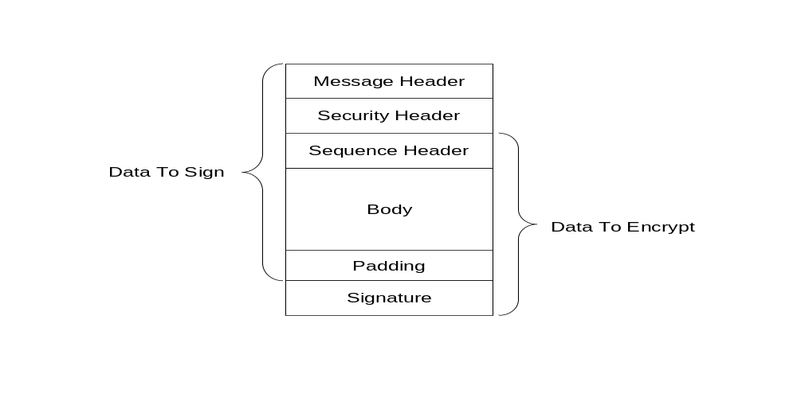
Figure 13 – OPC UA Secure Conversation MessageChunk
Every MessageChunk has a message header with the fields defined in Table 28.
Table 28 – OPC UA Secure Conversation Message Header
Name | Data Type | Description
MessageType | Byte[3] | A three byte ASCII code that identifies the message type.  The following values are defined at this time:  MSG A message secured with the keys associated with a channel.  OPN OpenSecureChannel message.  CLO CloseSecureChannel message.
IsFinal | Byte | A one byte ASCII code that indicates whether the MessageChunk is the final chunk in a message.  The following values are defined at this time:  C An intermediate chunk.  F The final chunk.  A The final chunk (used when an error occurred and the message is aborted).
MessageSize | UInt32 | The length of the MessageChunk, in bytes. This value includes size of the message header.
SecureChannelId | UInt32 | A unique identifier for the SecureChannel assigned by the server.  If a Server receives a SecureChannelId which it does not recognize it shall return an appropriate transport layer error.

The message header is followed by a security header which specifies what cryptography operations have been applied to the message. There are two versions of the security header which depend on the type of security applied to the Message. The security header used for asymmetric algorithms is defined in Table 29. Asymmetric algorithms are used to secure the OpenSecureChannel messages. PKCS #1 defines a set asymmetric algorithms that may be used by UASC implementations.
Table 29 – Asymmetric Algorithm Security Header
Name | Data Type | Description
SecurityPolicyUriLength | Int32 | The length of the SecurityPolicyUri in bytes.This value shall not exceed 255 bytes.
SecurityPolicyUri | Byte[*] | The URI of the security policy used to secure the message.  This field is encoded as a UTF8 string without a null terminator.
SenderCertificateLength | Int32 | The length of the SenderCertificate in bytes.  This value shall not exceed MaxCertificateSize bytes.
SenderCertificate | Byte[*] | The X509v3 certificate assigned to the sending application instance.  This is a DER encoded blob.  The structure of an X509 certificate is defined in X509.  The DER format for a certificate is defined in X690  This indicates what private key was used to sign the MessageChunk.  The Stack shall close the channel and report an error to the application if the SenderCertificate is too large for the buffer size supported by the transport layer.  This field shall be null if the message is not signed.
ReceiverCertificateThumbprintLength | Int32 | The length of the ReceiverCertificateThumbprint in bytes.  The length of this field is always 20 bytes.
ReceiverCertificateThumbprint | Byte[*] | The thumbprint of the X509v3 certificate assigned to the receiving application instance.  The thumbprint is the SHA1 digest of the DER encoded form of the certificate.  This indicates what public key was used to encrypt the MessageChunk.  This field shall be null if the message is not encrypted.

The receiver shall close the communication channel if any of the fields in the security header have invalid lengths.
The SenderCertificate shall be small enough to fit into a single MessageChunk and leave room for at least one byte of body information. The maximum size for the SenderCertificate can be calculated with this formula:
MaxCertificateSize = MessageChunkSize – AsymmetricSignatureSize - SecurityPolicyUriLength - SenderCertificateLength – ReceiverCertificateThumbprintLength – 3*Int32FieldLength
The MessageChunkSize depends on the transport protocol but shall be at least 8196 bytes, The AsymmetricSignatureSize depends on the number of bits in the public key for the SenderCertificate. The Int32FieldLength is the length of an encoded Int32 value and it is always 4 bytes.
The security header used for symmetric algorithms defined in Table 30. Symmetric algorithms are used to secure all messages other than the OpenSecureChannel messages. FIPS 197define symmetric encryption algorithms that UASC implementations may use. FIPS 180-2and HMACdefine some symmetric signature algorithms.
Table 30 – Symmetric Algorithm Security Header
Name | Data Type | Description
TokenId | UInt32 | A unique identifier for the SecureChannel token used to secure the message.  This identifier is returned by the server in an OpenSecureChannel response message. If a Server receives a TokenId which it does not recognize it shall return an appropriate transport layer error.

The security header is always followed by the sequence header which is defined in Table 31. The sequence header ensures that the first encrypted block of every message sent over a channel will start with different data.
Table 31 – Sequence Header
Name | Data Type | Description
SequenceNumber | UInt32 | A monotonically increasing sequence number assigned by the sender to each MessageChunk sent over the SecureChannel.
RequestId | UInt32 | An identifier assigned by the client to OPC UA request Message. All MessageChunks for the request and the associated response use the same identifier.

SequenceNumbers may not be reused for any TokenId. The token lifetime should be short enough to ensure that this never happens, however, if it does the receiver should treat it as a transport error and force a reconnect.
The SequenceNumber shall also monotonically increase for all messages and shall not wrap around until it is greater than 4294966271 (UInt32.MaxValue – 1024). The first number after the wrap around shall be less than 1024. Note that this requirement means that SequenceNumbers do not reset when a new TokenId is issued.
The sequence header is followed by the message body which is encoded with the OPC UA Binary encoding as described in Section 5.2.6. The body may be split across multiple MessageChunks.
Each MessageChunk also has a footer with the fields defined in Table 32.
Table 32 – OPC UA Secure Conversation Message Footer
Name | Data Type | Description
PaddingSize | Byte | The number of padding bytes (not including the byte for the PaddingSize).
Padding | Byte[*] | Padding added to the end of the message to ensure length of the data to encrypt is an integer multiple of the encryption block size.  The value of each byte of the padding is equal to PaddingSize.
Signature | Byte[*] | The signature for the MessageChunk.  The signature includes the all headers, all message data, the PaddingSize and the Padding.

The formula to calculate the amount of padding depends on the amount of data that needs to be sent (called BytesToWrite). The sender shall first calculate the maximum amount of space available in the MessageChunk (called MaxBodySize) using the following formula:
MaxBodySize = PlainTextBlockSize * Floor((MessageChunkSize –
HeaderSize – SignatureSize - 1)/CipherTextBlockSize) –
SequenceHeaderSize;
Where the HeaderSize includes the MessageHeader and the SecurityHeader. The SequenceHeaderSize is always 8 bytes.
During encryption a block with a size equal to PlainTextBlockSize is processed to produce a block with size equal to CipherTextBlockSize. These values depend on the encryption algorithm and may be the same.
The UA message can fit into a single chunk if BytesToWrite is less than or equal to the MaxBodySize. In this case the PaddingSize is calculated with this formula:
PaddingSize = PlainTextBlockSize –
((BytesToWrite + SignatureSize + 1) % PlainTextBlockSize);
If the BytesToWrite is greater than MaxBodySize the sender shall write MaxBodySize bytes with a PaddingSize of 0. The remaining BytesToWrite – MaxBodySize bytes shall be sent in subsequent MessageChunks.
The PaddingSize and Padding fields are not present if the MessageChunk is not encrypted.

MessageChunks and Error Handling
Message chunks are sent as they are encoded. If an error occurs creating a chunk then the sender shall send a final chunk to the receiver that tells the receiver that an error occurred and that it should discard the previous chunks. The sender indicates that the chunk contains an error by setting the IsFinal flag to ‘A’ (for Abort). Table 33 specifies the contents of the message abort chunk.
Table 33 – OPC UA Secure Conversation Message Abort Body
Name | Data Type | Description
Error | UInt32 | The numeric code for the error.  This shall be one of the values listed in Table 40.
Reason | String | A more verbose description of the error.  This string shall not be more than 4096 characters.  A client shall ignore strings that are longer than this.

The receiver shall check the security on the abort chunk before processing it. If everything is ok then the receiver shall ignore the message but shall not close the SecureChannel. The client shall report the error back to the application as StatusCode for the request. If the client is the sender then it shall report the error without waiting for a response from the server.

Establishing a SecureChannel
Most messages require a SecureChannel to be established. A client does this by sending an OpenSecureChannel request to the server. The server shall validate the message and the ClientCertificate and return an OpenSecureChannel response. Some of the parameters defined for the OpenSecureChannel service are specified in the security header (see Clause 6.4.2) instead of the body of the message. For this reason, the OpenSecureChannel service is not the same as the one specified in the Part 4. Table 34 lists the parameters that appear in the body of the message.
Table 34 – OPC UA Secure Conversation OpenSecureChannel Service
Name | Data Type
Request
RequestHeader | RequestHeader
ClientProtocolVersion | UInt32
RequestType | SecurityTokenRequestType
SecurityMode | MessageSecurityMode
ClientNonce | ByteString
RequestedLifetime | Int32
Response
ResponseHeader | ResponseHeader
ServerProtocolVersion | UInt32
SecurityToken | ChannelSecurityToken
SecureChannelId | UInt32
TokenId | UInt32
CreatedAt | DateTime
RevisedLifetime | Int32
ServerNonce | ByteString

The ClientProtocolVersion and ServerProtocolVersion parameters are not defined in Part 4 and are added to the message to allow backward compatibility if the OPC UA-SecureConversation protocol or implementation needs to be updated in the future. Receivers always accept numbers greater than the latest version that they support. The receiver with the higher version number is expected to ensure backward compatibility.
The latest version number supported by a Stack implementation is assigned during the certification testing process. If significant security vulnerablities are found in the OPC UA Stack reference implementation then all Stack implementations will need to be retested and assigned a new version number. Implementations that have not been certified shall set the protocol version to 0.
If the OPC UA-SecureConversation protocol is used with the OPC UA-TCP protocol (see Clause 7.1) then the version numbers specified in the OpenSecureChannel messages shall be the same as the version numbers specifed in the OPC UA-TCP protocol Hello/Acknowledge messages. The receiver shall close the channel and report a Bad_ProtocolVersionUnsupported error if there is a mismatch.
The server shall return an error response as described in Clause 5.3 of Part 4 if there are any errors with the parameters specified by the client.
The RevisedLifetime tells the client when it shall renew the token by sending another OpenSecureChannel request. The client shall continue to accept the old token until it receives the OpenSecureChannel response. The server has to accept requests secured with the old token until that token expires or until it receives a message from the Client secured with the new token. The Server shall reject renew requests if the SenderCertificate is not the same as the one used to create the SecureChannel or if there is a problem decrypting or verifying the signature. The Client shall abandon the SecureChannel if the Certificate used to sign the response is not the same as the Certificate used to encrypt the request.
The OpenSecureChannel messages are not signed or encrypted if the SecurityMode is None. The nonces are ignored and should be set to null. The SecureChannelId and the TokenId are still assigned but no security is applied to messages exchanged via the channel. The token shall still be renewed before the RevisedLifetime expires. Receivers shall still ignore invalid or expired TokenIds.
If the communication channel breaks the Server shall maintain the secure channel long enough to allow the client to reconnect. The ReviseLifetime parameter also tells the client how long the Server will wait. If the Client cannot reconnect within that period it shall assume the SecureChannel has been closed.
The AuthenticationToken in the RequestHeader shall be set to null.
If an error occurs after the Server has verified message security if shall returned a ServiceFault instead of a OpenSecureChannel response. The ServiceFault message is described in Part 4 Section 7.24.
If the SecurityMode is not None then the Server shall verify that a SenderCertificate and a ReceiverCertificateThumbprint were specified in the SecurityHeader.

Deriving Keys
Once the SecureChannel is established the messages are signed and encrypted with keys derived from the nonces exchanged in the OpenSecureChannel call. These keys are derived by passing the nonces to a pseudo-random function which produces a sequence of bytes from a set of inputs. A pseudo-random function is represented by the following function declaration:
Byte[] PRF(Byte[] secret, Byte[] seed, Int32 length, Int32 offset)
Where length is the number of bytes to return and offset is a number of bytes from the beginning of the sequence.
The lengths of the keys that need to be generated depend on the SecurityPolicy used for the channel. The following information is specified by the SecurityPolicy:
- SigningKeyLength (from the DerivedSignatureKeyLength);
- EncryptingKeyLength (implied by the SymmetricEncryptionAlgorithm);
- EncryptingBlockSize (implied by the SymmetricEncryptionAlgorithm);
The parameters passed to the pseudo random function are specified in Table 35.
Table 35 – Cryptography Key Generation Parameters
Key | Secret | Seed | Length | Offset
ClientSigningKey | ServerNonce | ClientNonce | SigningKeyLength | 0
ClientEncryptingKey | ServerNonce | ClientNonce | EncryptingKeyLength | SigningKeyLength
ClientInitializationVector | ServerNonce | ClientNonce | EncryptingBlockSize | SigningKeyLength+ EncryptingKeyLength
ServerSigningKey | ClientNonce | ServerNonce | SigningKeyLength | 0
ServerEncryptingKey | ClientNonce | ServerNonce | EncryptingKeyLength | SigningKeyLength
ServerInitializationVector | ClientNonce | ServerNonce | EncryptingBlockSize | SigningKeyLength+ EncryptingKeyLength

The client keys are used to secure messages sent by the client. The server keys are used to secure messages sent by the server.
The SSL/TLS specification defines a pseudo random function called P_SHA1 which is used for some SecurityProfiles. The P_SHA1 algorithm is defined as follows:
P_SHA1(secret, seed) = HMAC_SHA1(secret, A(1) + seed) +
HMAC_SHA1(secret, A(2) + seed) +
HMAC_SHA1 (secret, A(3) + seed) + ...
Where A(n) is defined as:
A(0) = seed
A(n) = HMAC_SHA1(secret, A(n-1))
+ indicates that the results are appended to previous results.

Verifying Message Security
The contents of the MessageChunk shall not be interpreted until the message is decrypted and the signature and sequence number verified.
If error occurs during message verification the receiver shall close the communication channel. If the receiver is the Server it shall also send a transport error message before closing the channel. Once the channel is closed the Client shall attempt to re-open the channel and request a new token by sending an OpenSecureChannel request. The mechanism for sending transport errors to the Client depends on the communication channel.
The receiver shall first check the SecureChannelId. This value may be 0 if the message is an OpenSecureChannel request. For other messages it shall report a Bad_SecureChannelUnknown error if the SecureChannelId is not recognized. If the message is an OpenSecureChannel request and the SecureChannelId is not 0 then the SenderCertificate shall be the same as the SenderCertificate used to create the channel.
If the message is secured with asymmetric algorithms then the receiver shall verify that it supports the requested SecurityPolicy. If the message is the response sent to the Client then the SecurityPolicy shall be the same as the one specified in the request. In the Server the SecurityPolicy shall be the same as the one used to originally create the SecureChannel. The receiver shall then verify the SenderCertificate using the rules defined in Part 4 Section 6.1.4. The receiver shall report the appropriate error if Certificate validation fails. The receiver shall verify the ReceiverCertificateThumbprint and report a Bad_CertificateUnknown error if it does not recognize it.
If the message is secured with symmetric algorithms then a Bad_SecureChannelTokenUnknown error shall be reported if the TokenId refers to a token that has expired or is not recognized.
If decryption or signature validation fails then a Bad_SecurityChecksFailed error is reported. If an implementation allows multiple SecurityModes to be used the receiver shall also verify that the message was secured properly as required by the SecurityMode specified in the OpenSecureChannel request.
After the security validation is complete the receiver shall verify the RequestId and the SequenceNumber. If these checks fail a Bad_SecurityChecksFailed error is reported. The RequestId only needs to be verified by the Client since only the Client knows if it is valid or not.
At this point the SecureChannel knows it is dealing with an authenticated message that was not tampered with or resent. This means the SecureChannel can return a secured error response if any further problems are encountered.
Stacks that implement UASC shall have a mechanism to log errors when invalid messages are discarded. This mechanism is intended for developers, systems integrators and administrators to debug network system configuration issues and to detect attacks on the network.

Transport Protocols

OPC UA TCP

Overview
OPC UA TCP is a simple TCP based protocol that establishes a full duplex channel between a client and server. This protocol has two key features that differentiate it from HTTP. First, this protocol allows responses to be returned in any order. Second, this protocol allows responses to be returned on a different socket if communication failures causes temporary socket interruption.
The OPC UA TCP protocol is designed to work with the SecureChannel implemented by a layer higher in the stack. For this reason, the OPC UA TCP protocol defines its interactions with the SecureChannel in addition to the wire protocol.

Message Structure
Every OPC UA TCP message has a header with the fields defined in Table 36.
Table 36 – OPC UA TCP Message Header
Name | Type | Description
MessageType | Byte[3] | A three byte ASCII code that identifies the message type.  The following values are defined at this time:  HEL a Hello message.  ACK an Acknowledge message.  ERR an Error message.  The SecureChannel layer defines additional values which the OPC UA TCP layer shall accept.
Reserved | Byte[1] | Ignored. shall be set to the ASCII codes for ‘F’ if the MessageType is one of the values supported by the OPC UA TCP protocol.
MessageSize | UInt32 | The length of the message, in bytes. This value includes the 8 bytes for the message header.

The layout of the OPC UA TCP message header is intentionally identical to the first 8 bytes of the OPC UA Secure Conversation message header defined in Table 28. This allows the OPC UA TCP layer to extract the SecureChannel messages from the incoming stream even if it does not understand their contents.
The OPC UA TCP layer shall verify the MessageType and make sure the MessageSize is less than the negotiated ReceiveBufferSize before passing any message onto the SecureChannel layer.
The Hello message has the additional fields shown in Table 37.
Table 37 – OPC UA TCP Hello Message
Name | Data Type | Description
ProtocolVersion | UInt32 | The latest version of the OPC UA TCP protocol supported by the Client.  The Server may reject the Client by returning Bad_ProtocolVersionUnsupported.  If the Server accepts the connection is responsible for ensuring that it returns messages that conform to this version of the protocol.  The Server shall always accept versions greater than what it supports.
ReceiveBufferSize | UInt32 | The largest message that the sender can receive.  This value shall be greater than 8192 bytes.
SendBufferSize | UInt32 | The largest message that the sender will send.  This value shall be greater than 8192 bytes.
MaxMessageSize | UInt32 | The maximum size for any response message. The server shall abort the message with a Bad_ResponseTooLarge StatusCode if a response message exceeds this value.  The mechanism for aborting messages is described fully in Clause 6.4.3.  The message size is calculated using the unencrypted message body.  A value of zero indicates that the Client has no limit.
MaxChunkCount | UInt32 | The maximum number of chunks in any response message.  The server shall abort the message with a Bad_ResponseTooLarge StatusCode if a response message exceeds this value.  The mechanism for aborting messages is described fully in Clause 6.4.3.  A value of zero indicates that the Client has no limit.
EndpointUrl | String | The URL of the Endpoint which the Client wished to connect to.  The encoded value shall be less than 4096 bytes.  Servers shall return a Bad_TcpUrlRejected error and close the connection if the length exceeds 4096 or if it does not recognize the resource identified by the URL.

The EndpointUrl parameter is used to allow multiple servers to share the same port on a machine. The process listening (a.k.a. proxy) on the port would connect to the Server identified by the EndpointUrl and would forward all messages to the Server via this socket. If one socket closes then the proxy shall close the other socket.
The Acknowledge message has the additional fields shown in Table 38.
Table 38 – OPC UA TCP Acknowledge Message
Name | Type | Description
ProtocolVersion | UInt32 | The latest version of the OPC UA TCP protocol supported by the Server.  If the Client accepts the connection is responsible for ensuring that it sends messages that conform to this version of the protocol.  The Client shall always accept versions greater than what it supports.
ReceiveBufferSize | UInt32 | The largest message that the sender can receive.  This value shall not be larger than what the Client requested in the Hello message.  This value shall be greater than 8192 bytes.
SendBufferSize | UInt32 | The largest message that the sender will send.  This value shall not be larger than what the Client requested in the Hello message.  This value shall be greater than 8192 bytes.
MaxMessageSize | UInt32 | The maximum size for any request message. The client shall abort the message with a Bad_RequestTooLarge StatusCode if a request message exceeds this value.  The mechanism for aborting messages is described fully in Clause 6.4.3.  The message size is calculated using the unencrypted message body.  A value of zero indicates that the Server has no limit.
MaxChunkCount | UInt32 | The maximum number of chunks in any request message.  The client shall abort the message with a Bad_RequestTooLarge StatusCode if a request message exceeds this value.  The mechanism for aborting messages is described fully in Clause 6.4.3.  A value of zero indicates that the Server has no limit.

The Error message has the additional fields shown in Table 39.
Table 39 – OPC UA TCP Error Message
Name | Type | Description
Error | UInt32 | The numeric code for the error.  This shall be one of the values listed in Table 40.
Reason | String | A more verbose description of the error.  This string shall not be more than 4096 characters.  A client shall ignore strings that are longer than this.

Figure 14 illustrates the structure of a message placed on the wire. This includes also illustrates how the message elements defined by the OPC UA Binary Encoding mapping (see 5.2) and the OPC UA Secure Conversation mapping (see 6.4) relate to the OPC UA TCP messages.
The socket is always closed gracefully by the Server after it sends an Error message.
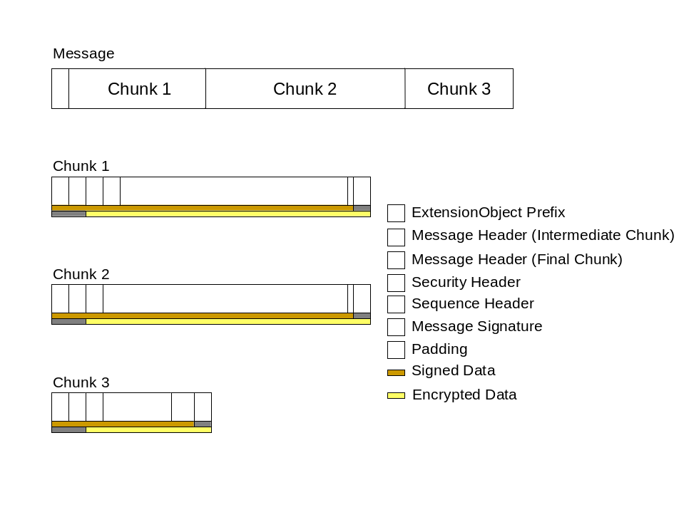
Figure 14 – OPC UA TCP Message Structure

Establishing a Connection
Connections are always initiated by the client which creates the socket before it sends the first OpenSecureChannel request. After creating the socket the first message sent shall be a Hello which specifies the buffer sizes that the client supports. The server shall respond with an Acknowledge message which completes the buffer negotiation. The negotiated buffer size shall be reported to the SecureChannel layer. The negotiated SendBufferSize specifies the size of the MessageChunks to use for messages sent over the connection.
The Hello/Acknowledge messages may only be sent once. If they are received again the receiver shall report an error and close the socket. Servers shall close any socket after a period of time if it does not receive a Hello message. This period of time shall be configurable and have a default value which does not exceed two minutes.
The client sends the OpenSecureChannel request once it receives the Acknowledge back from the server. If the server accepts the new channel it shall associate the socket with the SecureChannelId. The server uses this association to determine which socket to use when it has to send a response to the client. The client does the same when it receives the OpenSecureChannel response.
The sequence of messages when establishing a OPC UA TCP connection are shown in Figure 15.
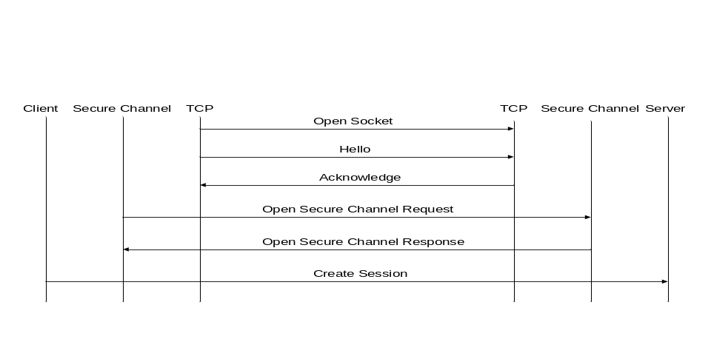
Figure 15 – Establishing a OPC UA TCP Connection

Closing a Connection
The client closes the connection by sending a CloseSecureChannel request and closing the socket gracefully. When the server receives this message it shall release all resources allocated for the channel. The server does not send a CloseSecureChannel response.
If security verification fails for the CloseSecureChannel message then the Server shall report the error and close the socket. The Server shall allow the Client to attempt to reconnect.
The sequence of messages when closing a OPC UA TCP connection are shown in Figure 16.
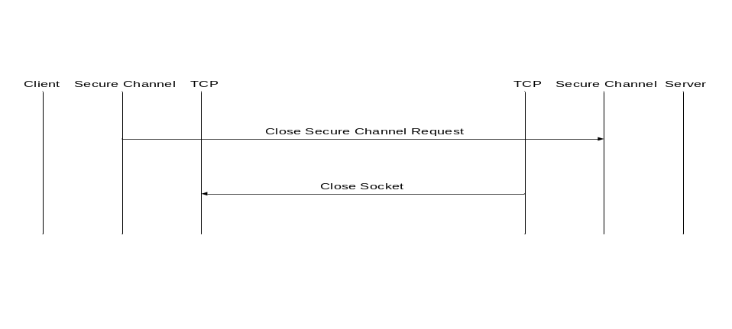
Figure 16 – Closing a OPC UA TCP Connection

Error Handling
When a fatal error occurs the server shall send an Error message to the client and close the socket. When a client encounters one of these errors, it shall also close the socket but does not send an Error message. After the socket is closed a client shall try to reconnect automatically using the mechanisms described in Clause 7.1.6.
The possible OPC UA TCP errors are defined in Table 40.
Table 40 – OPC UA TCP Error Codes
Name | Description
TcpServerTooBusy | The server cannot process the request because it is too busy.  It is up to the server to determine when it needs to return this message.  A server can control the how frequently a client reconnects by waiting to return this error.
TcpMessageTypeInvalid | The type of the message specified in the header invalid.  Each message starts with a 4 byte sequence of ASCII values that identifies the message type.  The server returns this error if the message type is not accepted.  Some of the message types are defined by the SecureChannel layer.
TcpSecureChannelUnknown | The SecureChannelId and/or TokenId are not currently in use.  This error is reported by the SecureChannel layer.
TcpMessageTooLarge | The size of the message specified in the header is too large.  The server returns this error if the message size exceeds its maximum buffer size or the receive buffer size negotiated during the Hello/Acknowledge exchange.
TcpTimeout | A timeout occurred while accessing a resource.  It is up to the server to determine when a timeout occurs.
TcpNotEnoughResources | There are not enough resources to process the request.  The server returns this error when it runs out of memory or encounters similar resource problems.  A server can control the how frequently a client reconnects by waiting to return this error.
TcpInternalError | An internal error occurred.  This should only be returned if an unexpected configuration or programming error occurs.
TcpUrlRejected | The Server does not recognize the EndpointUrl specified.
SecurityChecksFailed | The message was rejected because it could not be verified.
RequestInterrupted | The request could not be sent because of a network interruption.
RequestTimeout | Timeout occurred while processing the request.
SecureChannelClosed | The secure channel has been closed.
SecureChannelTokenUnknown | The token has expired or is not recognized.
CertificateUntrusted | The sender certificate is not trusted by the receiver.
CertificateTimeInvalid | The sender certificate has expired or is not yet valid.
CertificateIssuerTimeInvalid | The issuer for the sender certificate has expired or is not yet valid.
CertificateUseNotAllowed | The sender’s certificate may not be used for establishing a secure channel.
CertificateIssuerUseNotAllowed | The issuer certificate may not be used as a Certificate Authority.
CertificateRevocationUnknown | Could not verify the revocation status of the sender’s certificate.
CertificateIssuerRevocationUnknown | Could not verify the revocation status of the issuer certificate.
CertificateRevoked | The sender certificate has been revoked by the issuer.
IssuerCertificateRevoked | The issuer certificate has been revoked by its issuer.
CertificateUnknown | The receiver certificate thumbprint is not recognized by the receiver.

The numeric values for these error codes are defined in A.2.

Error Recovery
Once the SecureChannel has been established, the client shall go into a error recovery state whenever the socket breaks or if the server returns an OPC UA TCP Error message as defined in Table 39. While in this state the client periodically attempts to reconnect to the server. If the reconnect succeeds the client sends a Hello followed by an OpenSecureChannel request (see Clause 6.4.4) that re-authenticates the client and associates the new socket with the existing SecureChannel.
The client shall wait between reconnect attempts. The first reconnect shall happen immediately. After that the wait period should start as 1 second and increase gradually to a maximum of 2 minutes. One sequence would double the period each attempt until reaching the maximum. In other words, the client would use the following wait periods: { 0, 1, 2, 4, 8, 16, 32, 64, 120, 120, …}. The client shall keep attempting to reconnect until the SecureChannel is closed or after the period equal to the RevisedLifetime of the last SecurityToken elapses.
The stack in the server should not discard responses if there is no connection immediately available. It should wait and see if the client creates a new socket. It is up to the server stack implementation to decide how long it will wait and how many responses it is willing to hold onto.
The stack in the Client shall not fail requests that have already been sent and are waiting for a response when the socket is closed, however, these requests may timeout and report a Bad_TcpRequestTimeout error to the application. If the client sends a new request the stack shall either buffer the request or return a Bad_TcpRequestInterrupted error. The client can stop the reconnect process by closing the SecureChannel.
The Server may abandon the SecureChannel before a Client is able to reconnect. If this happens the Client will get a Bad_TcpSecureChannelUnknown error in response to the OpenSecureChannel request. The stack shall return this error to the application that can attempt to create a new SecureChannel.
The negotiated buffer sizes should never change when a connection is recovered, however, the buffer sizes are negotiated before the server knows whether the socket is being used for an existing SecureChannel or a new one. A client shall treat this as a fatal error, closes the SecureChannel and returns an Bad_TcpSecureChannelClosed error to the application.
The sequence of messages when recovering an OPC UA TCP connection are shown in Figure 17.
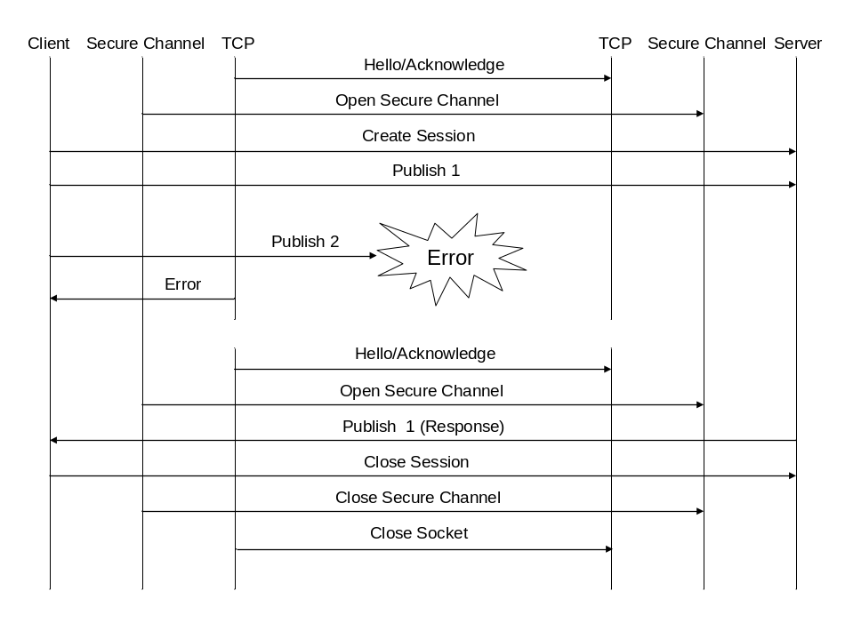
Figure 17 – Recovering an OPC UA TCP Connection

SOAP/HTTP

Overview
SOAP describes an XML based syntax for exchanging messages between applications. OPC UA messages are exchanged using SOAP by serializing the OPC UA messages using one of the supported encodings described in Clause 5 and inserting that encoded message into the body of the SOAP message.
All OPC UA applications that support the SOAP/HTTP transport shall support SOAP 1.2 as described in SOAP Part 1.
All OPC UA messages are exchanged using the request-response message exchange pattern defined in SOAP Part 2 even if the OPC UA service does not specify any output parameters. In these cases, the server shall return an empty response message that tells the client that no errors occurred.
WS-I Basic Profile 1.1 defines best practices when using SOAP messages which will help ensure interoperability. All OPC UA implementations shall conform to this specification.
HTTP is the network communication protocol used to exchange SOAP messages. An OPC UA service request message is always sent by the client in the body of an HTTP POST request. The server returns an OPC UA response message in the body of the HTTP response. The HTTP binding for SOAP is described completely in SOAP Part 2.
HTTPS is a variant of HTTP that encrypts and/or signs HTTP messages using the SSL/TLS protocol. HTTPS provides a efficient way to encrypt data sent across the network when two applications can communicate directly without intermediaries.
OPC UA does not define any SOAP headers, however, SOAP messages containing OPC UA messages will include headers used by the other WS specifications in the stack.
SOAP faults are returned only for errors that occurred with in the SOAP stack. Errors that occur within in the application are returned as OPC UA error response messages as described in Clause 5.3 of Part 4.
WS Addressing defines standard headers used to route SOAP messages through intermediaries. Implementations shall support the WS-Addressing headers listed Table 41.
Table 41 – WS-Addressing Headers
Header | Request | Response
wsa:To | Required | Optional
wsa:From | Optional | Optional
wsa:ReplyTo | Required | Not Used
wsa:Action | Required | Required
wsa:MessageID | Required | Optional
wsa:RelatesTo | Not Used | Required
Note that WS-Addressing defines standard URIs to use in the ReplyTo and From headers when a client does not have an externally accessible endpoint. In these cases, the SOAP response is always returned to the client using the same communication channel that sent the request.
OPC UA servers shall ignore the wsa:FaultTo header if it is specified in a request.

XML Encoding
The OPC UA XML Encoding specifies a way to represent an OPC UA message as an XML element. This element is added to the SOAP message as the only child of the SOAP body element.
If an error occurs in the server while parsing the request body, the server may return a SOAP fault or it may return an OPC UA error response.
The SOAP Action associated with an XML encoded request message always has the form:
http://opcfoundation.org/UA/<service name>
Where <service name> is the name of the OPC UA service being invoked.
The SOAP Action associated with an XML encoded response message always has the form:
http://opcfoundation.org/UA/<service name>Response

OPC UA Binary Encoding
The OPC UA Binary Encoding specifies a way to represent an OPC UA message as a sequence of bytes. These bytes sequences shall be encoded in the SOAP body using the Base64data format.
The Base64 data format is a UTF-7 representation of binary data that is less efficient than raw binary data, however, many OPC UA applications that exchange messages using SOAP will find that encoding OPC UA messages in OPC UA Binary and then encoding the binary in Base64 is more efficient than encoding everything in XML.
The WSDL definition for a UA Binary encoded request message is:
<xs:element name="InvokeService" type="xs:base64Binary" nillable="true" />

<wsdl:message name="InvokeServiceMessage">
<wsdl:part name="InvokeService" element="tns:InvokeService" />
</wsdl:message>
The SOAP Action associated with a OPC UA Binary encoded request message always has the form:
http://opcfoundation.org/UA/InvokeService

The WSDL definition for an OPC UA Binary encoded response message is:
<xs:element name="InvokeServiceResponse" type="xs:base64Binary"
nillable="true" />

<wsdl:message name="InvokeServiceResponseMessage">
<wsdl:part name="InvokeServiceResponse" element="tns:InvokeServiceResponse" />
</wsdl:message>

The SOAP Action associated with an OPC UA Binary encoded response message always has the form:
http://opcfoundation.org/UA/InvokeServiceResponse

Normative Contracts

OPC Binary Schema
The normative contract for the OPC UA Binary encoded messages is an OPC Binary Schema. This file defines the structure of all types and messages. The syntax for an OPC Binary Type Schema is described in Appendix B of Part 3. This schema captures normative names for types and their fields as well the order the fields appear when encoded. The data type of each field is also captured.

XML Schema and WSDL
The normative contract for the OPC UA XML encoded messages is an XML Schema. This file defines the structure of all types and messages. This schema captures normative names for types and their fields as well the order the fields appear when encoded. The data type of each field is also captured.
The normative contract for message sent via the SOAP/HTTP TransportProtocol is a WSDL that includes XML Schema for the OPC UA XML encoded messages. It also defines the port types for OPC UA Servers and DiscoveryServers.
The WSDL and XML Schema files are attached in Error: Reference source not found.
- Constants
  - Attribute Ids
Table 42 – Identifiers Assigned to Attributes
Attribute | Identifier
NodeId | 1
NodeClass | 2
BrowseName | 3
DisplayName | 4
Description | 5
WriteMask | 6
UserWriteMask | 7
IsAbstract | 8
Symmetric | 9
InverseName | 10
ContainsNoLoops | 11
EventNotifier | 12
Value | 13
DataType | 14
ValueRank | 15
ArrayDimensions | 16
AccessLevel | 17
UserAccessLevel | 18
MinimumSamplingInterval | 19
Historizing | 20
Executable | 21
UserExecutable | 22
  - Status Codes
This appendix defines the numeric identifiers for all of the StatusCodes defined by the OPC UA Specification. The identifiers are specified in a CSV file with the following syntax:
<SymbolName>, <SubCode>
Where the SymbolName is the literal name for the error code that appears in the specification and the SubCode is numeric value for the SubCode field within a StatusCode (See Clause 7.33 in Part 4). The severity associated with particular code is specified by the prefix (Good, Uncertain or Bad).
The CSV associated with this version of the specification can be found here:
http://www.opcfoundation.org/UAPart6/2008/02/StatusCodes.csv
The most recent set of StatusCodes can be found here:
http://www.opcfoundation.org/UAPart6/StatusCodes.csv
  - Numeric Node Ids
This appendix defines the numeric identifiers for all of the numeric NodeIds defined by the OPC UA Specification. The identifiers are specified in a CSV file with the following syntax:
<SymbolName>, <Identifier>, <NodeClass>
Where the SymbolName is either the BrowseName of a Type Node or the BrowsePath for an Instance Node that appears in the specification and the Identifier is numeric value for the NodeId.
The BrowsePath for an instance Node is constructed by appending the BrowseName of the instance Node to BrowseName for the containing instance or type. A ‘_’ character is used to separate each BrowseName in the path. For example, Part 5 defines the ServerType ObjectType Node which has the NamespaceArray Property. The SymbolName for the NamespaceArray InstanceDeclaration within the ServerType declaration is: ServerType_NamespaceArray. Part 5 also defines a standard instance of the ServerType ObjectType with the BrowseName ‘Server’. The BrowseName for the NamespaceArray Property of the standard Server Object is: Server_NamespaceArray.
The NamespaceUri for all NodeIds defined here is http://opcfoundation.org/UA/
The CSV associated with this version of the specification can be found here:
http://www.opcfoundation.org/UAPart6/2008/02/NodeIds.csv
The most recent set of NodeIds can be found here:
http://www.opcfoundation.org/UAPart6/NodeIds.csv
- Type Declarations for the OPC UA Native Mapping
This appendix defines the OPC UA Binary encoding for all DataTypes and Messages defined in the specification. The schema used to describe the type is defined in Appendix C of Part 3.
The OPC UA Binary Schema associated with this version of the specification can be found here:
http://www.opcfoundation.org/UAPart6/2008/02/Types.bsd.xml
The most recent OPC UA Binary Schema can be found here:
http://www.opcfoundation.org/UAPart6/Types.bsd.xml
- WSDL for the XML Mapping
  - XML Schema
This appendix defines the XML Schema for all DataTypes and Messages defined in the specification.
The XML Schema associated with this version of the specification can be found here:
http://www.opcfoundation.org/UAPart6/2008/02/Types.xsd
The most recent XML Schema can be found here:
http://www.opcfoundation.org/UAPart6/Types.xsd
  - WDSL Port Types
This appendix defines the WSDL Operations and Port Types for all Services defined in Part 4.
The WSDL associated with this version of the specification can be found here:
http://www.opcfoundation.org/UAPart6/2008/02/PortTypes.wsdl
The most recent WSDL can be found here:
http://www.opcfoundation.org/UAPart6/PortTypes.wsdl
This WSDL imports the XML Schema defined in C.1.
  - WSDL Bindings
This appendix defines the WSDL Bindings for all Services defined in Part 4.
The WSDL associated with this version of the specification can be found here:
http://www.opcfoundation.org/UAPart6/2008/02/Bindings.wsdl
The most recent WSDL can be found here:
http://www.opcfoundation.org/UAPart6/Bindings.wsdl
This WSDL imports the WSDL defined in C.2.

This is the same as the binary representation of the WIN32 FILETIME type, within the OPC UA allowed range. UTC is the timezone used for the starting time

